School Name
Mathematics Test 2017
Year 9 |  | Linear Equations | Non Calculator
Skills and Knowledge Assessed:  - Substitute values into formulas to determine an unknown (ACMNA234)  - Solve problems involving linear equations, including those derived from formulas (ACMNA235)  - Solve linear inequalities and graph their solutions on a number line (ACMNA236)  - Solve linear equations involving simple algebraic fractions (ACMNA240) |  |  | Name_________________
Section 1 Short Answer Section
Write all working and answers in the spaces provided on this test paper.

Solve 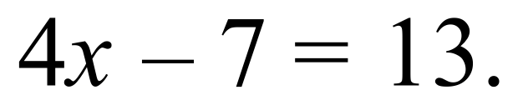

……………………………………………………………………………………………....

……………………………………………………………………………………………….
Solve 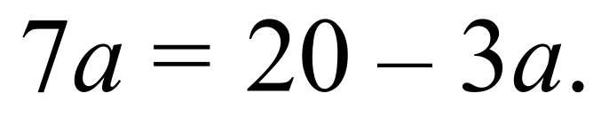

……………………………………………………………………………………………....

……………………………………………………………………………………………….
Find the value of m for which 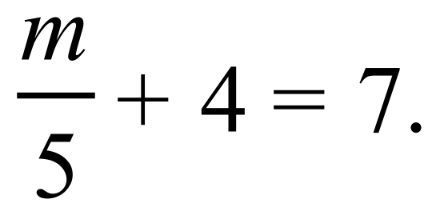

……………………………………………………………………………………………....

……………………………………………………………………………………………….
Solve 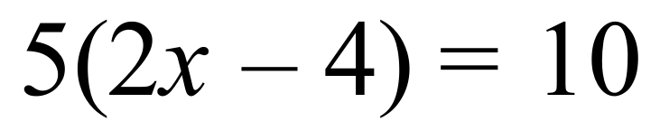.

……………………………………………………………………………………………....

……………………………………………………………………………………………….
Given the formula 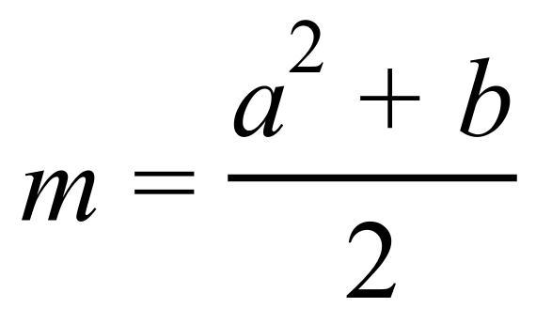, find the value of m when a = 3 and b = 15.

……………………………………………………………………………………………....

……………………………………………………………………………………………….
Solve 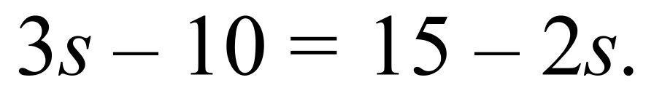

……………………………………………………………………………………………....

……………………………………………………………………………………………….
Sketch the inequality 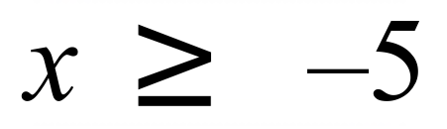 on the number line below.

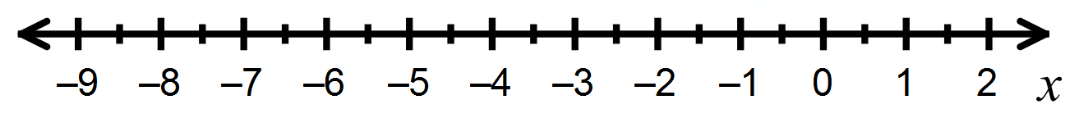

Using the formula 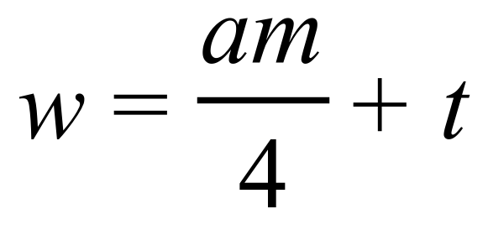 find the value of m, when w = 25, a = 3 and t =19.

……………………………………………………………………………………………....

……………………………………………………………………………………………....

……………………………………………………………………………………………….
Determine whether 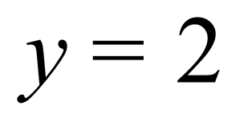 is a solution to the equation 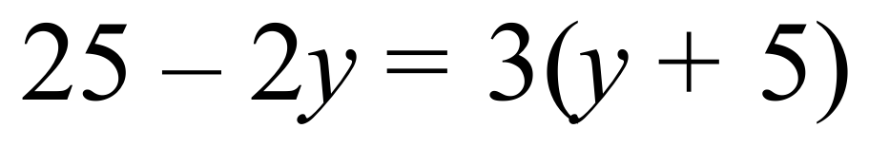.
Show the working that you use to decide on your answer.

……………………………………………………………………………………………....

……………………………………………………………………………………………….
Solve 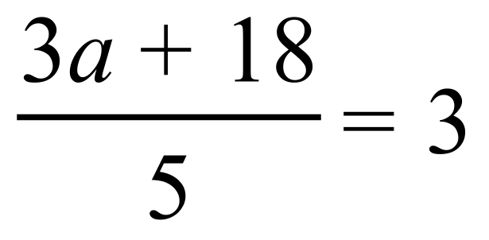.

……………………………………………………………………………………………....

……………………………………………………………………………………………….

……………………………………………………………………………………………….

……………………………………………………………………………………………….
Solve 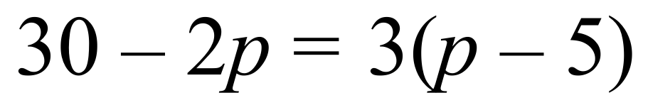 .

……………………………………………………………………………………………....

……………………………………………………………………………………………....

……………………………………………………………………………………………....

……………………………………………………………………………………………….
Solve 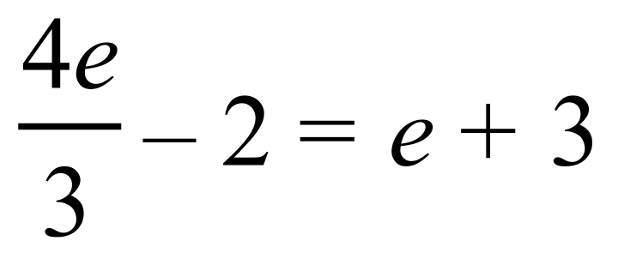.
……………………………………………………………………………………………....

……………………………………………………………………………………………….

……………………………………………………………………………………………….

……………………………………………………………………………………………….
Given the formula 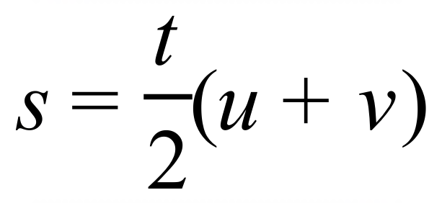, find the value of u when s = 24, t = 5 and v = 6.

……………………………………………………………………………………………….

……………………………………………………………………………………………….

……………………………………………………………………………………………....

……………………………………………………………………………………………….
Solve the inequality 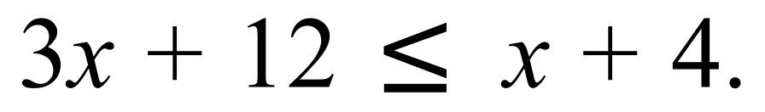

……………………………………………………………………………………………....

……………………………………………………………………………………………....

……………………………………………………………………………………………....

……………………………………………………………………………………………….
Solve 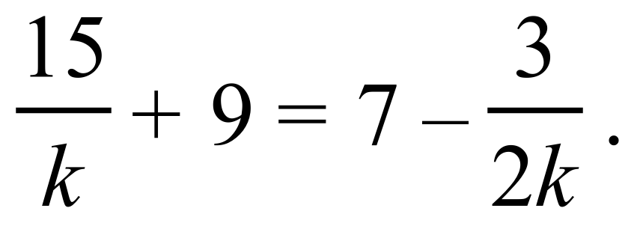

……………………………………………………………………………………………....

……………………………………………………………………………………………….

……………………………………………………………………………………………....

……………………………………………………………………………………………….

School Name
Mathematics Test 2017
Year 9 |  | Linear Equations | Calculator Allowed
 |  | Linear Equations | Name_________________
Section 2 Multiple Choice Section
Mark all your answers on the accompanying multiple choice answer sheet, not on this test paper. You may do any working out on this test paper. Calculators are allowed for this section.

Solve 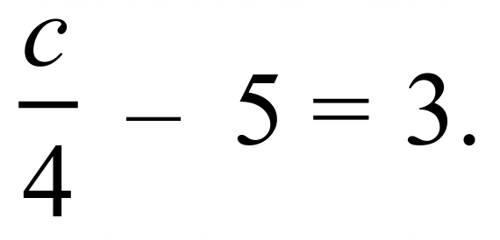

A. c = –8 B. c = – ½ C. c = 2 D. c = 32
For what value of k is 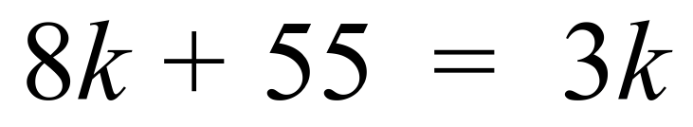?

A. k = –11 B. k = –5 C. k = –1 D. k = 5
Which is the first incorrect line in the following solution?

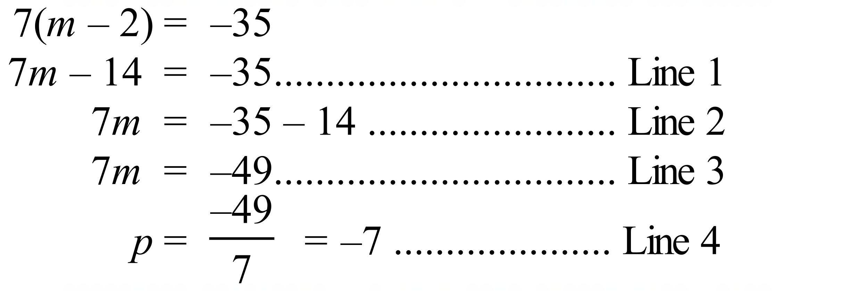

A. Line 1 B. Line 2 C. Line 3 D. Line 4
Use the formula 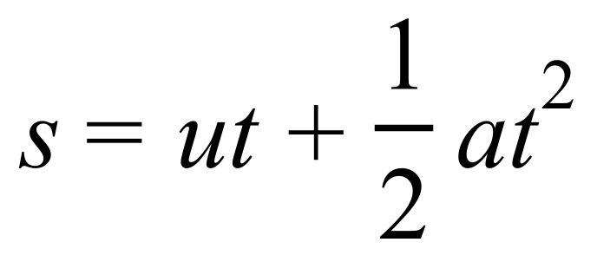 to find the value of s when u = 6, a = 10 and t = 5.

A. 95 B. 155 C. 185 D. 655
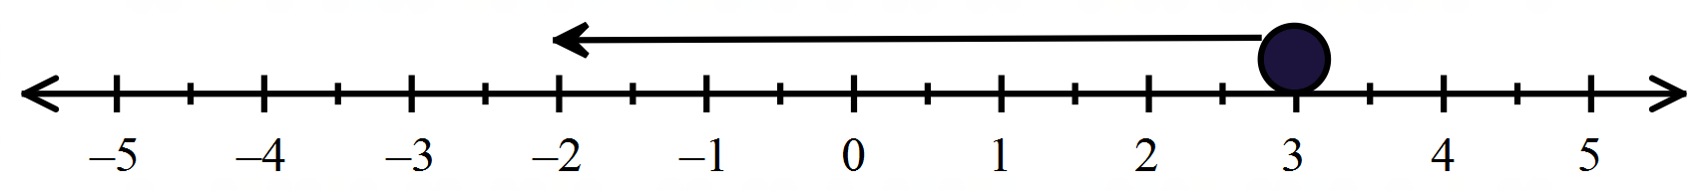

A. 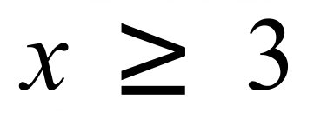 B. 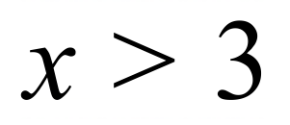 C. 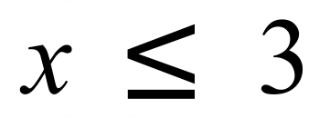 D. 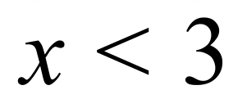
Solve 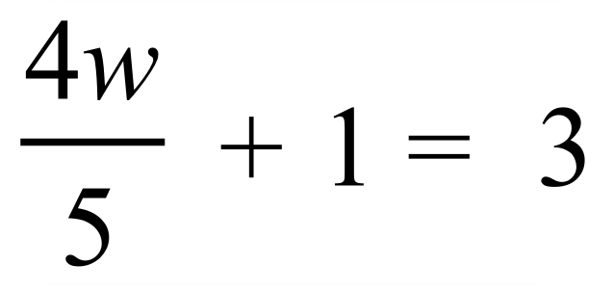.

A. 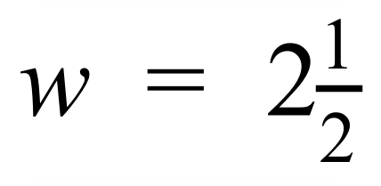 B. w = 3 C. 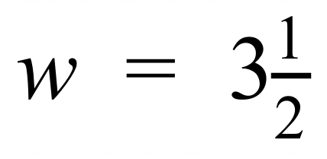 D. w = 5
Solve 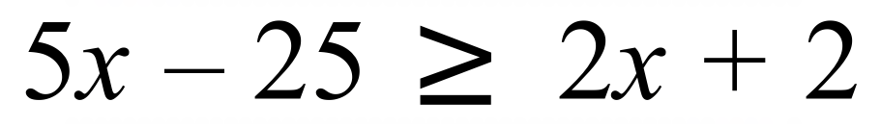.

A. 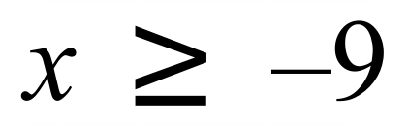 B. 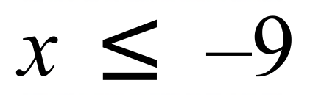 C. 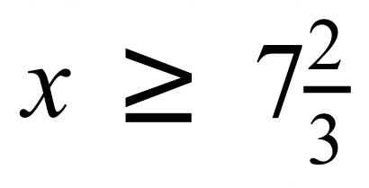 D. 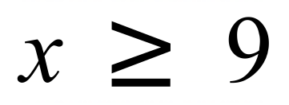
To test if z =6 is the correct solution to the equation 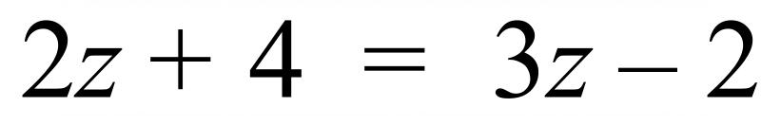, Jason completes the following 4 steps.
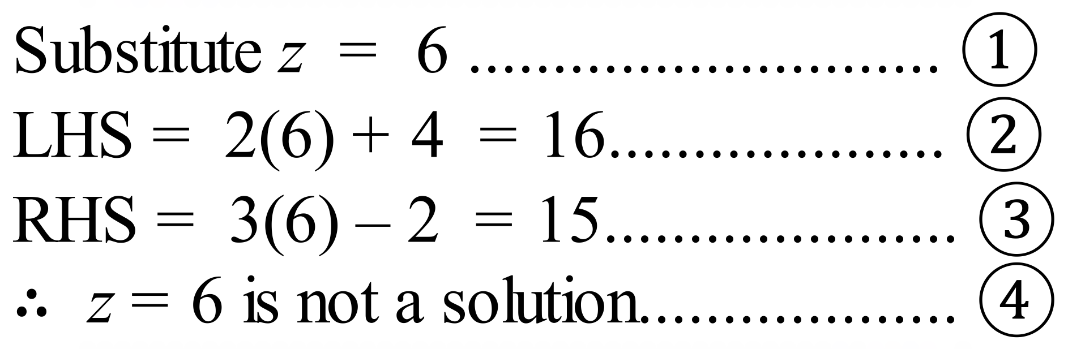
In which step did he first make an error?

A. 
B. 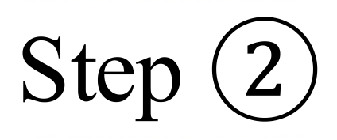
C. 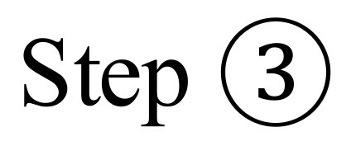
D. 
Which number line graph gives the solution to 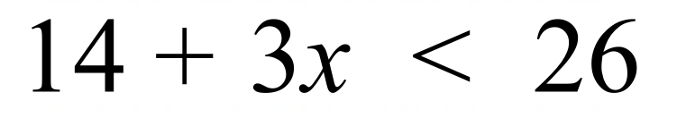?
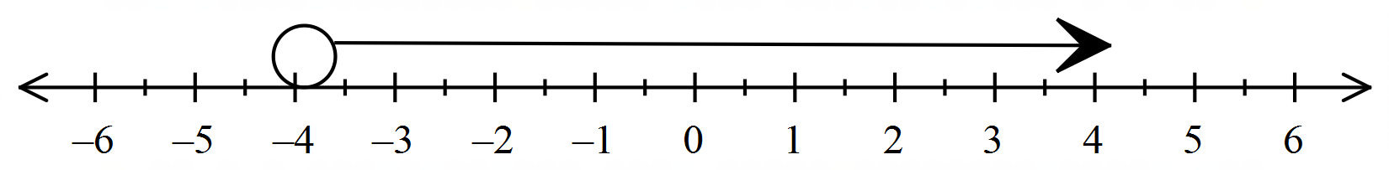
A.

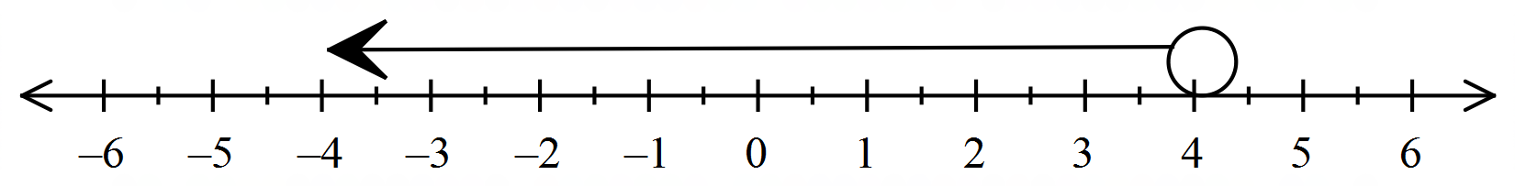
B.

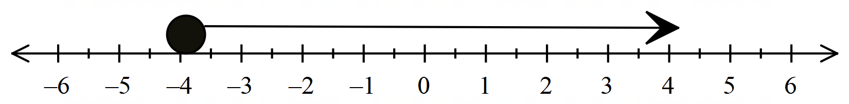
C.

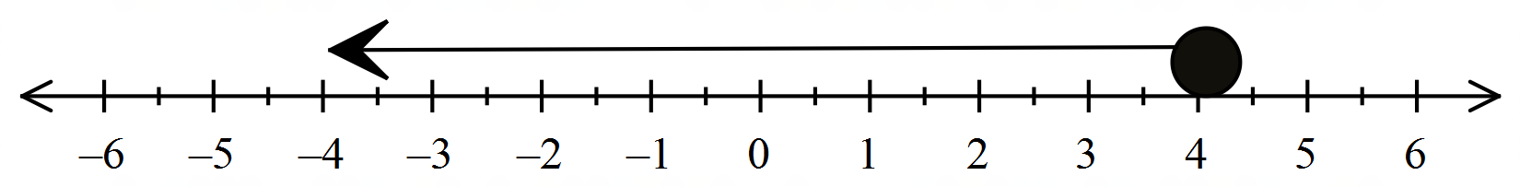
D.

Use the formula 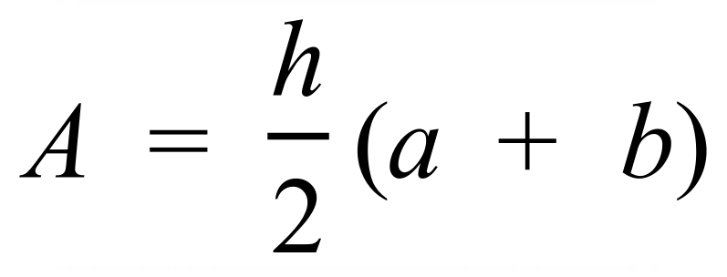 to find the value of b, when A = 228, h = 6 and a = 20.

A. b = 28 B. b = 42 C. b = 56 D. b = 112
Use the formula 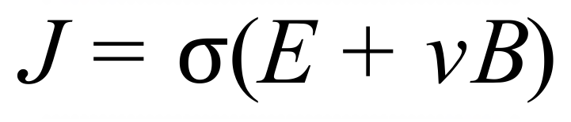 to find the value of B when J = 3020, 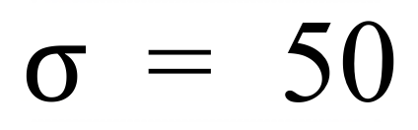, E = 6.4 and v = 12.

A. B = 4.5 B. B = 9 C. B = 112.5 D. B = 225
Solve 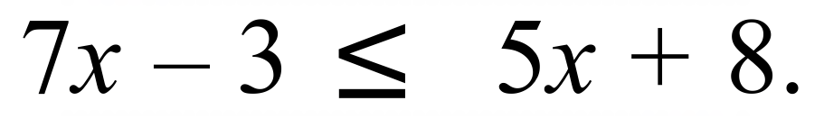

A. 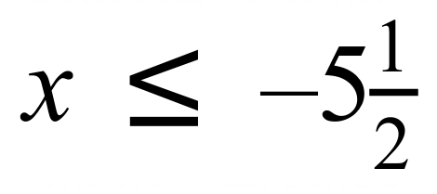 B. 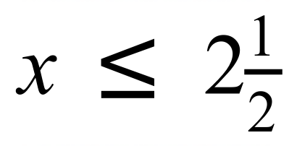 C. 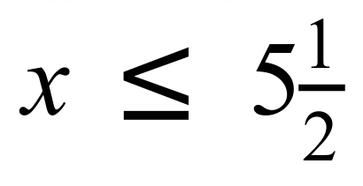 D. 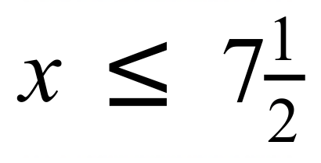
Using the formula 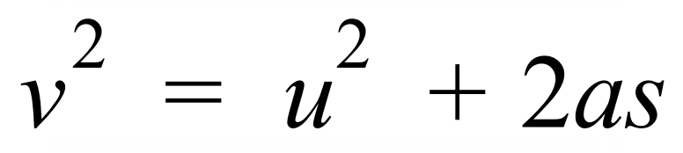 find the value of u when v = –6, a = 3 and s = 6.

A. 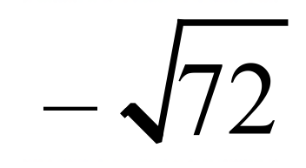 B. 0 C. 6 D. 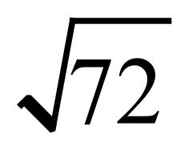
Solve 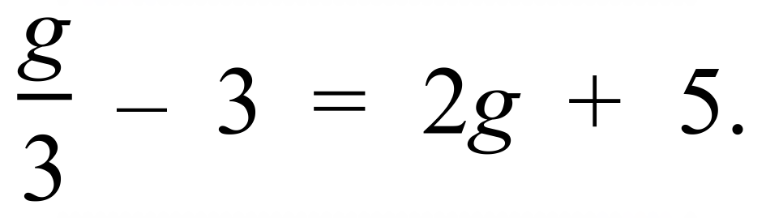

A. 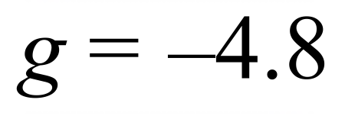 B. 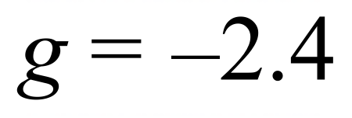 C. 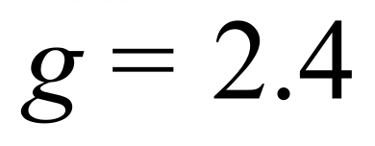 D. 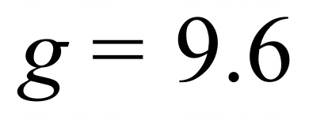
Solve 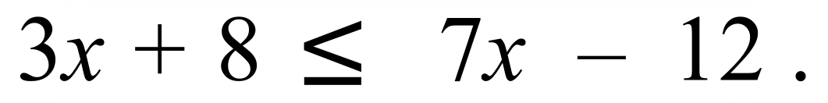

A. 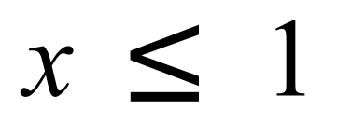 B. 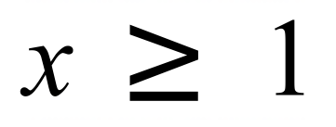 C. 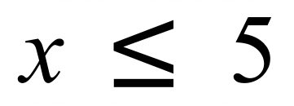 D. 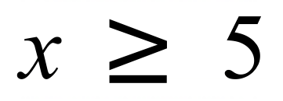

School Name
Mathematics Test 2017
Year 9 | Linear Equations | Calculator Allowed
Year 9 | Linear Equations | Name___________________
Section 3 Longer Answer Section
Write all working and answers in the spaces provided on this test paper.

 |  | Marks
1. | (a) Solve : 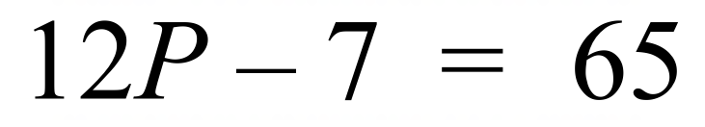  …………………………………………….……………………………………………  ……………………………………………….………………………………………… | 2
 | (b) Solve : 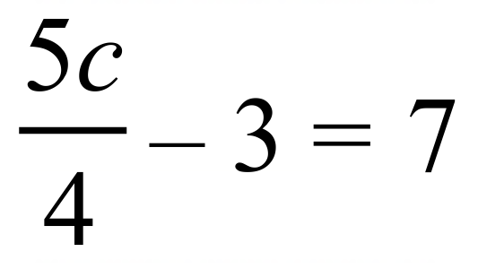.  …………………………………………….……………………………………………  …………………………………………….……………………………………………  ……………………………………………….………………………………………… | 2
 | (c) Solve : 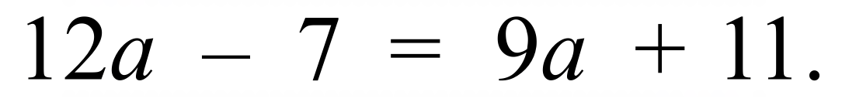  …………………………………………….……………………………………………  …………………………………………….……………………………………………  ……………………………………………….………………………………………… | 2
 | (d) Use the formula 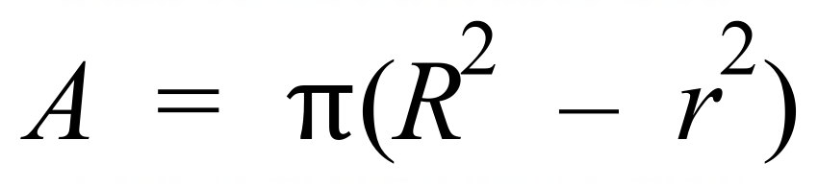 to find the value of A when 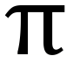 = 3.14, R = 13 and r = 6.  …………………………………………….……………………………………………  ……………………………………………….…………………………………………  ……………………………………………….………………………………………… | 2
2. | (a) Solve: 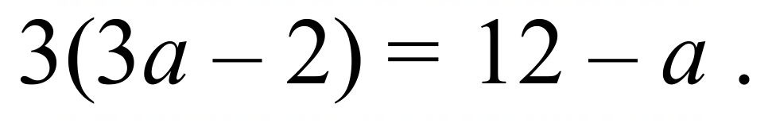  ……………………………………………………………………………………………....  ……………………………………………………………………………………………….  ……………………………………………………………………………………………....  ………………………………………………………………………………………………. | 3
 | (b) Solve and graph the solution to 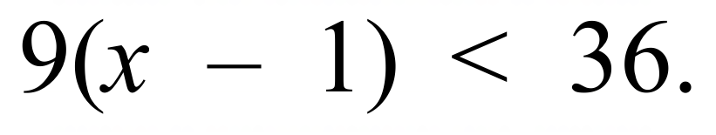 .  ……………………………………………………………………………………………....  ……………………………………………………………………………………………....  ……………………………………………………………………………………………....  ………………………………………………………………………………………………. | 3
 | (c) Solve : 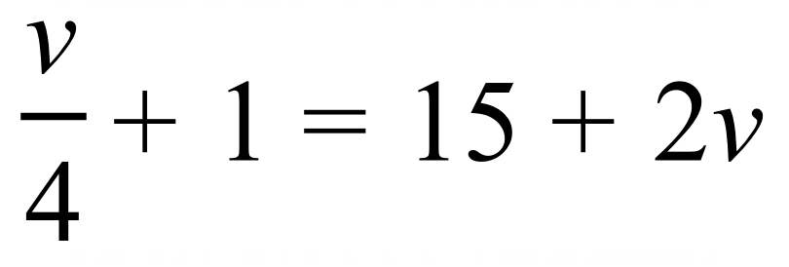  …………………………………………….……………………………………………  …………………………………………….……………………………………………  …………………………………………….……………………………………………  ……………………………………………….………………………………………… | 3
 | (d) Use the formula 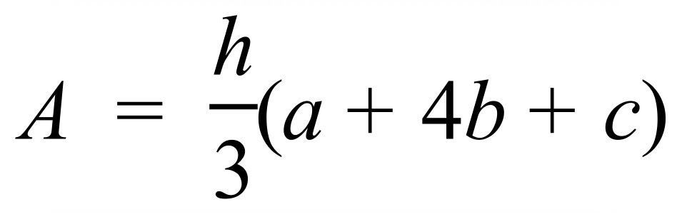 to find the value of b, when A = 190, h = 6, a = 10 and c = 25.  …………………………………………….……………………………………………  …………………………………………….……………………………………………  …………………………………………….……………………………………………  ……………………………………………….………………………………………… | 3
3. | (a) Solve : 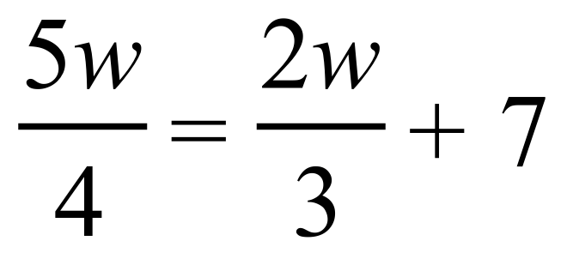.  ……………………………………………………………………………………………....  ……………………………………………………………………………………………....  ……………………………………………………………………………………………....  ……………………………………………………………………………………………....  ………………………………………………………………………………………………. | 3
 | (b) Owen has two pieces of cable. The longer piece is 3 metres less than 4 times the length of the shorter. The sum of their lengths is 150 m.  (i) If s is the length of the shorter cable, write an expression for the length of the longer.  ……………………………………………………………………………………………....  ……………………………………………………………………………………………....  (ii) Write an equation and solve it to find the lengths of the two cables.  ……………………………………………………………………………………………....  ……………………………………………………………………………………………....  ……………………………………………………………………………………………....  ……………………………………………………………………………………………....  ………………………………………………………………………………………………. | 1  2
 | (c) Solve : 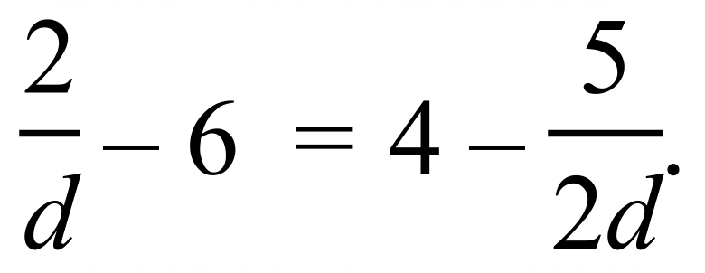 .  ……………………………………………………………………………………………....  ……………………………………………………………………………………………....  ……………………………………………………………………………………………....  ……………………………………………………………………………………………....  ………………………………………………………………………………………………. | 3
 | (d) Solve : 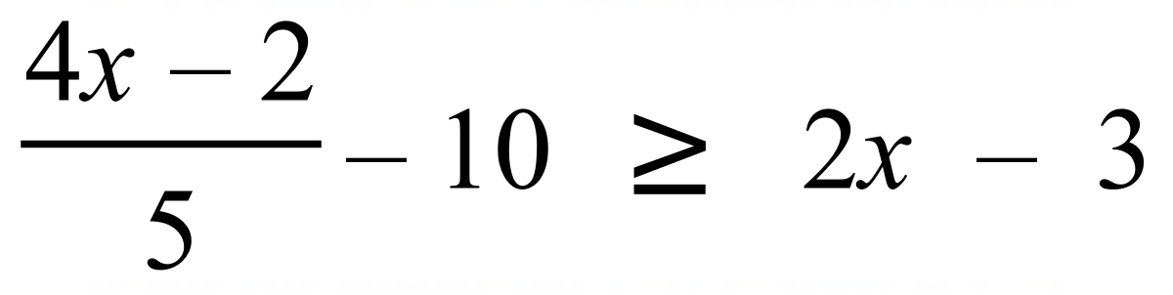  ……………………………………………………………………………………………....  ……………………………………………………………………………………………....  ……………………………………………………………………………………………....  ……………………………………………………………………………………………....  ………………………………………………………………………………………………. | 3

School Name
Mathematics 2017
Multiple Choice Answer Sheet
Linear Equations
Name _____________________________________________
Completely fill the response oval representing the most correct answer.
1. A B C D
2. A B C D
3. A B C D
4. A B C D
5. A B C D
6. A B C D
7. A B C D
8. A B C D
9. A B C D
10. A B C D
11. A B C D
12. A B C D
13. A B C D
14. A B C D
15. A B C D

School Name
Mathematics Test 2017
Year 9 | Linear Equations | Non Calculator Section
ANSWERS

Question | Working and Answer
 | 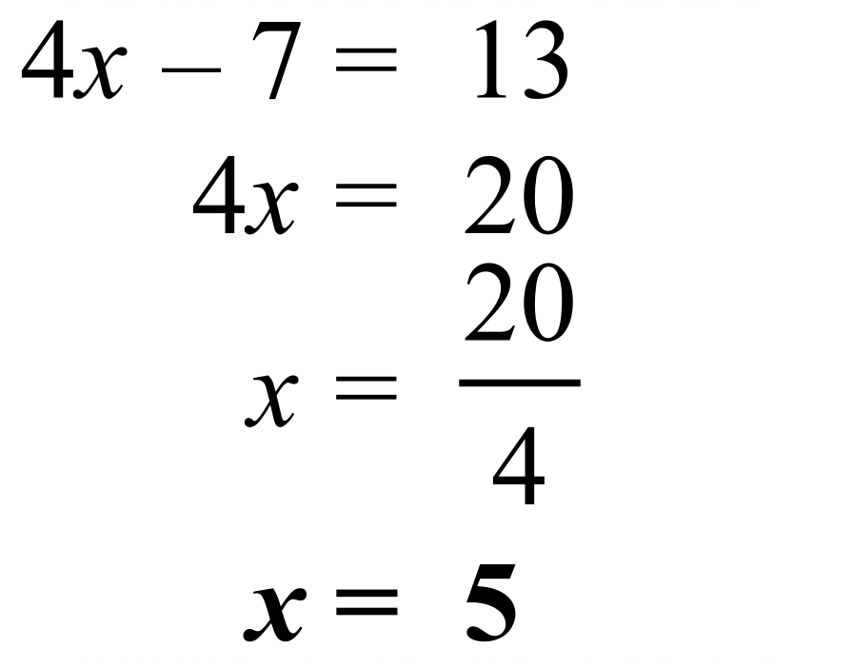
 | 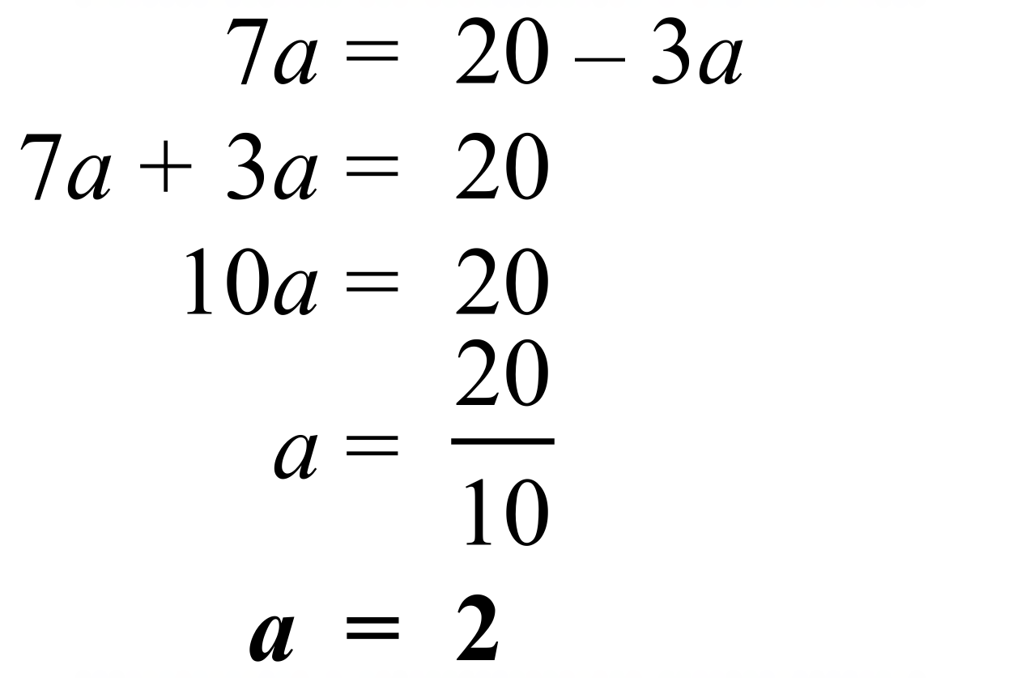
 | 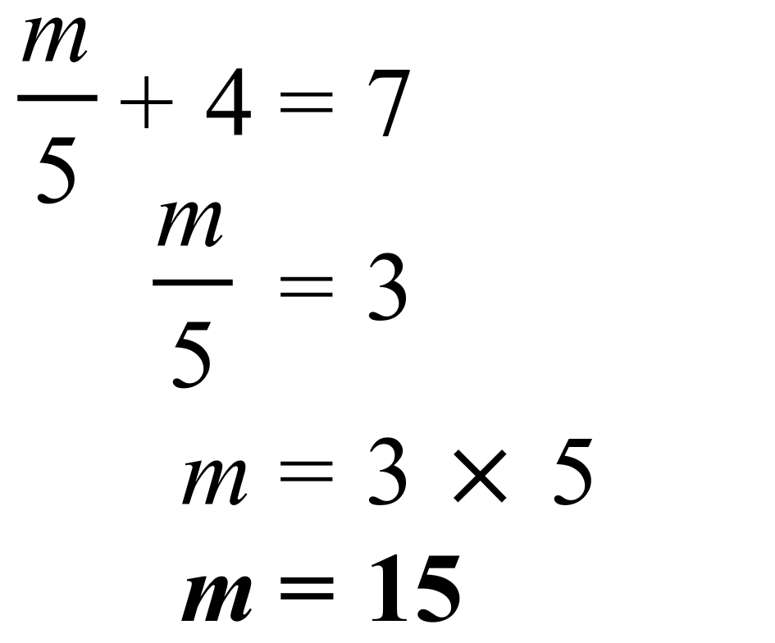
 | 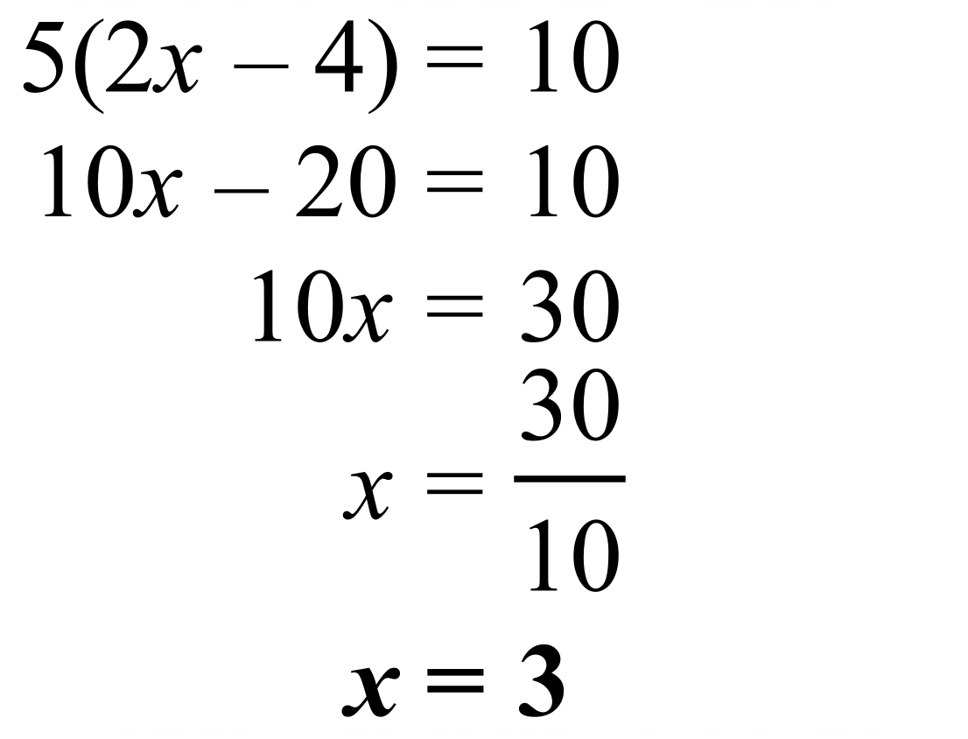.
 | 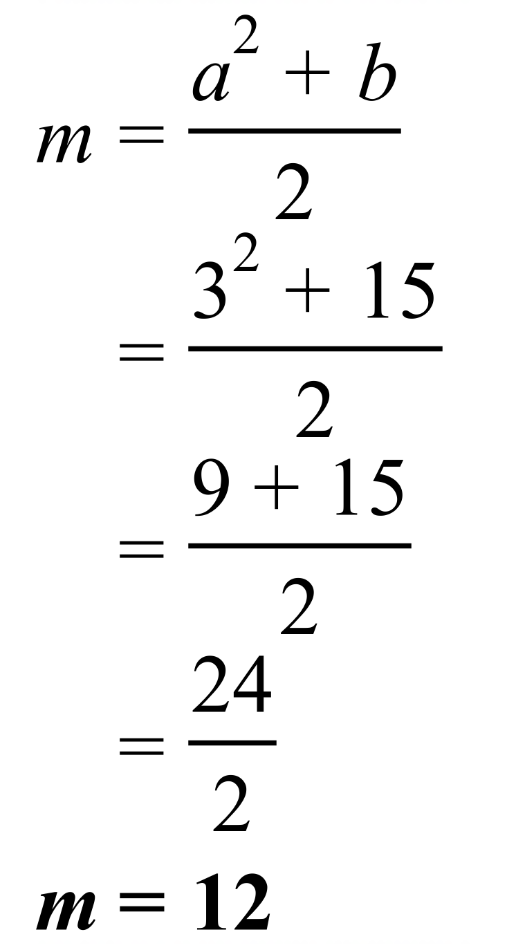,
 | 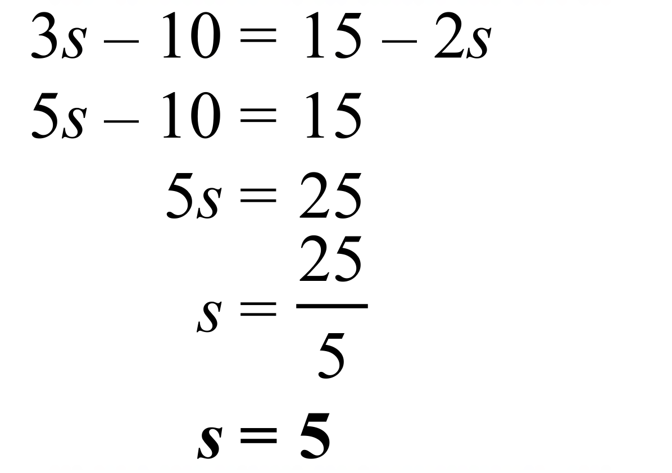
 | 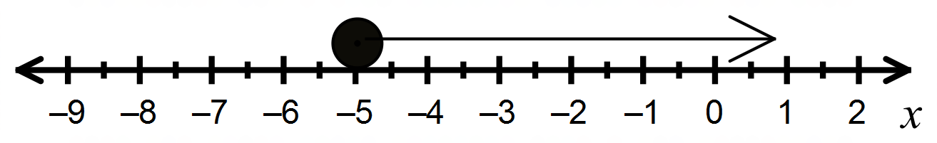
 | 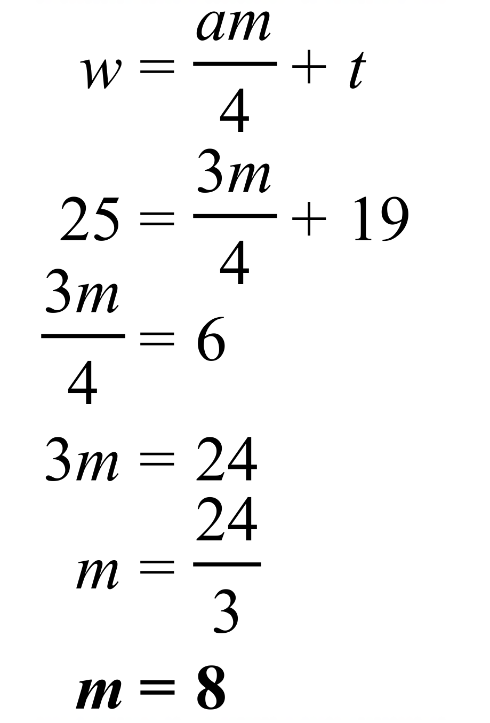
 | 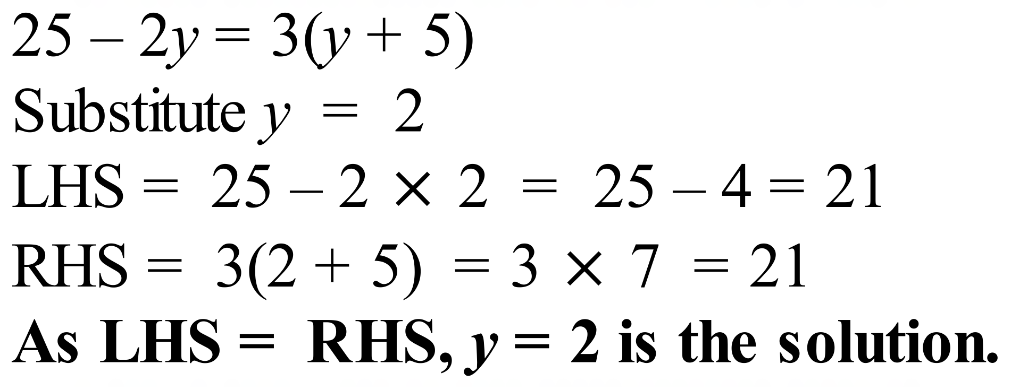.
 | 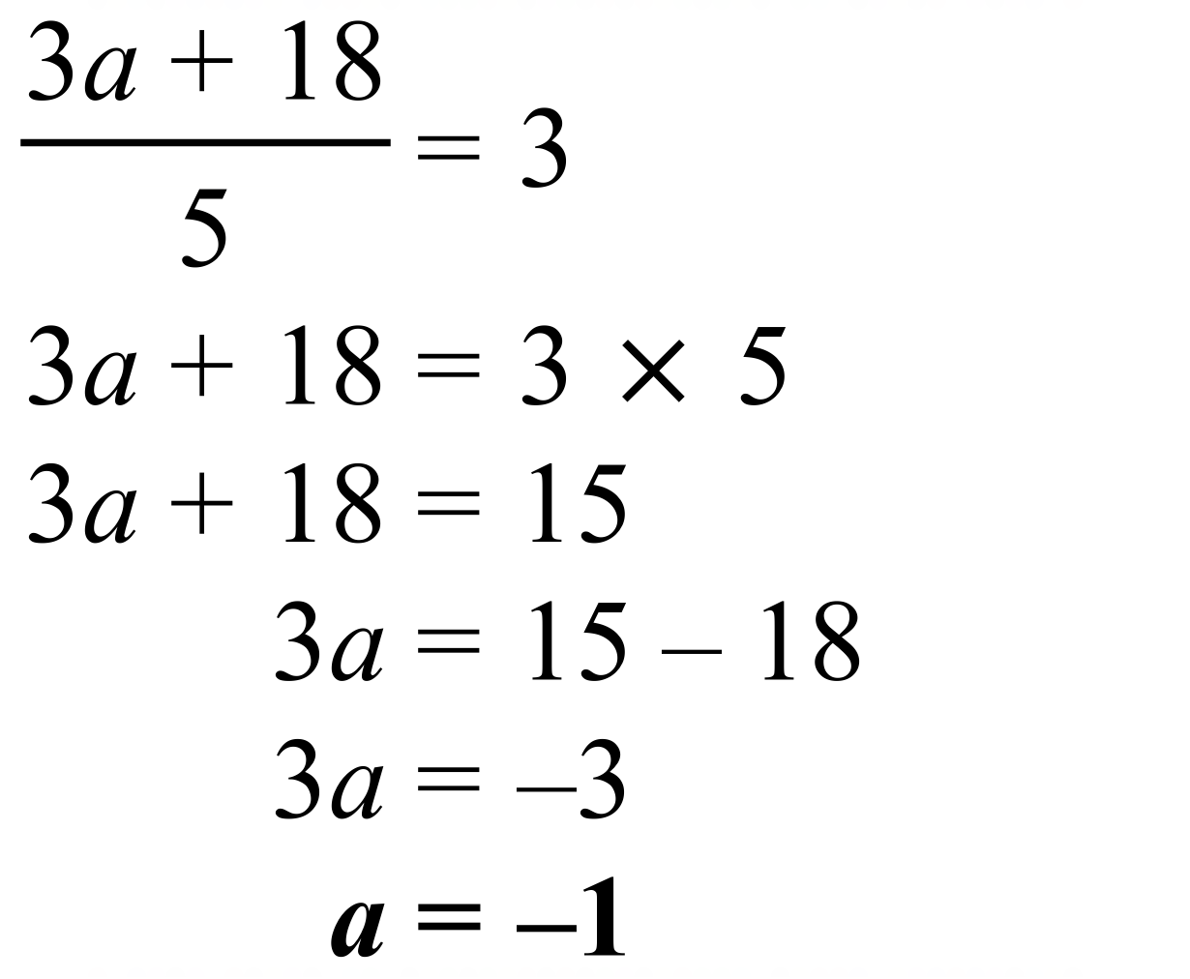.
 | 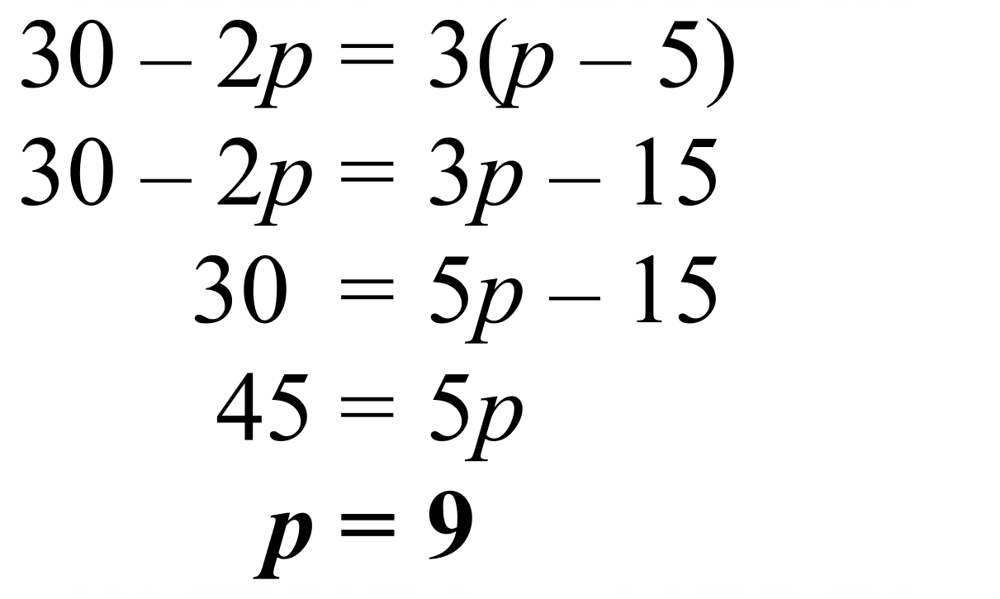
 | 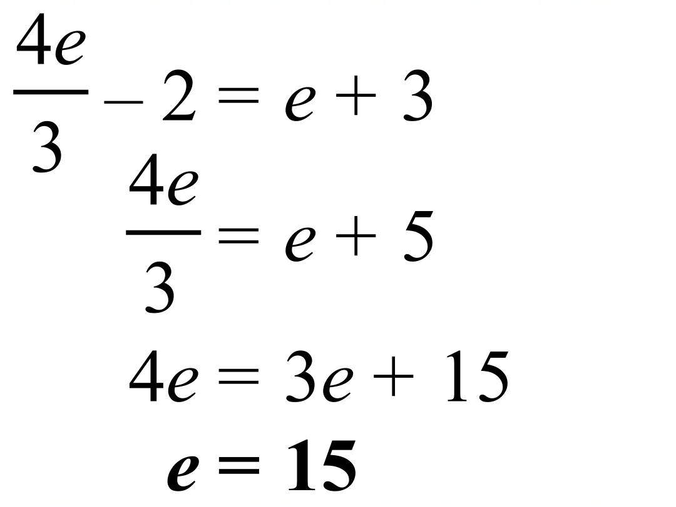
 | 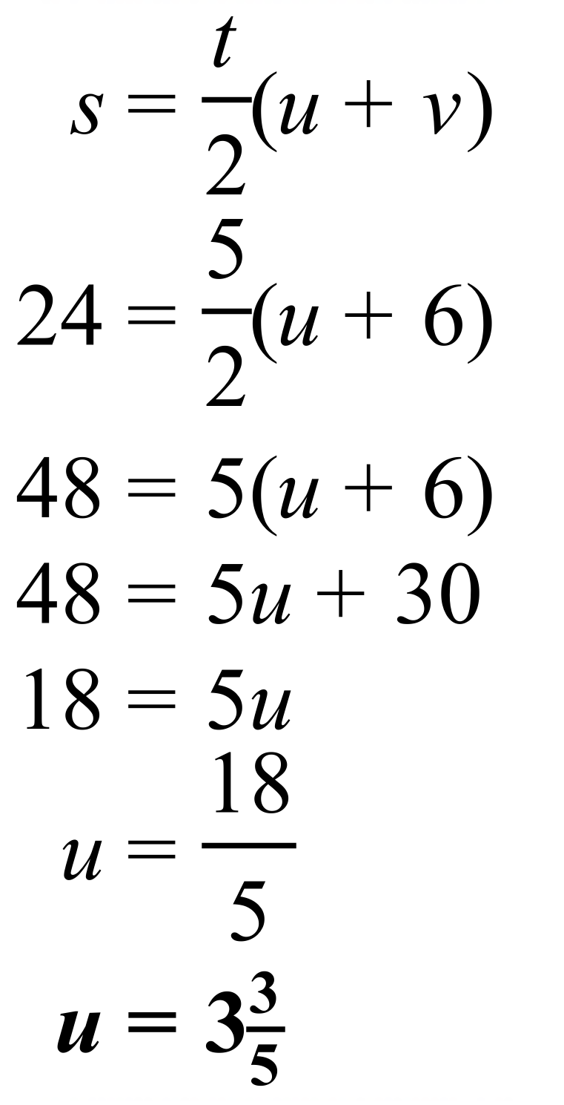
 | 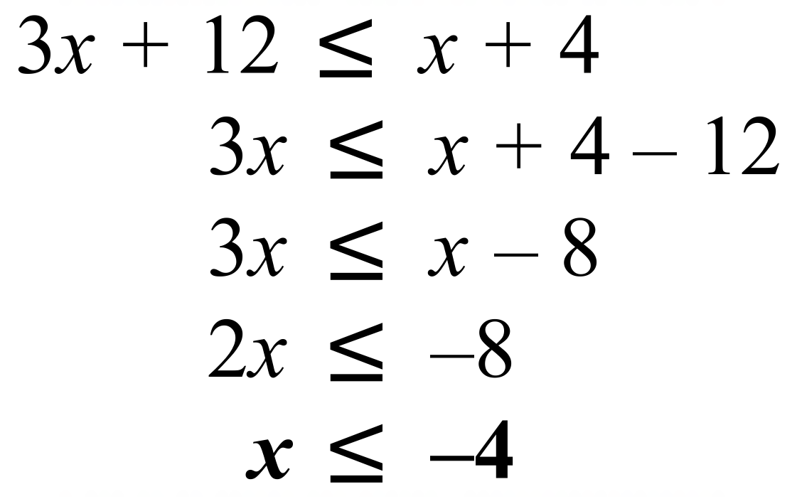
 | 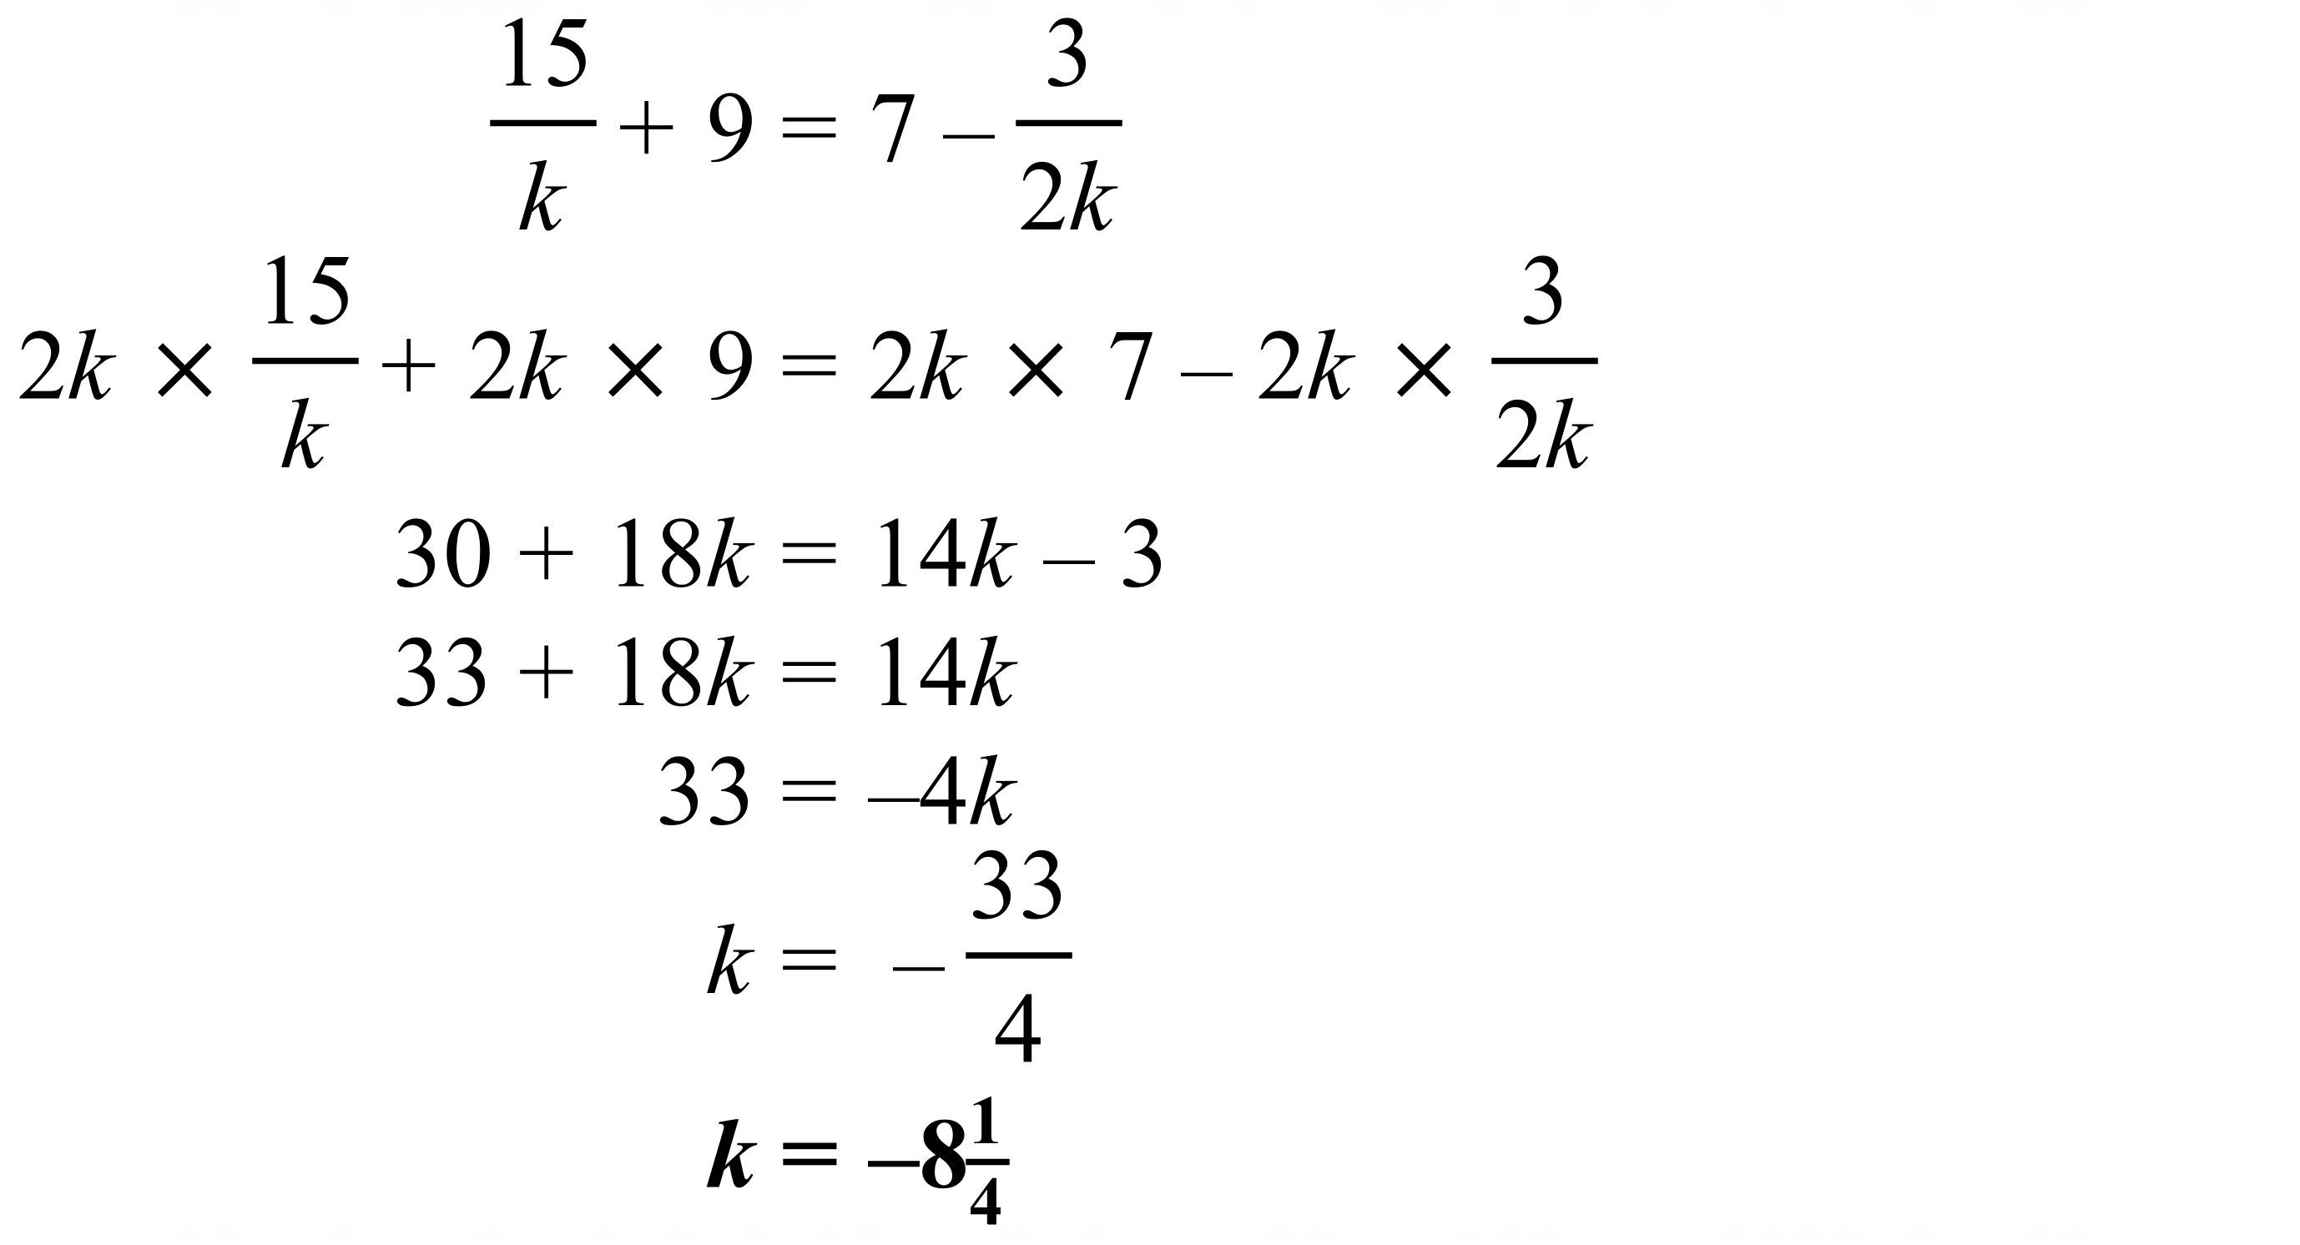

School Name
Mathematics Test 2017
Year 9 | Linear Equations | Calculator Allowed  Multiple Choice  Section

ANSWERS

Question | Working | M C Answer
 | 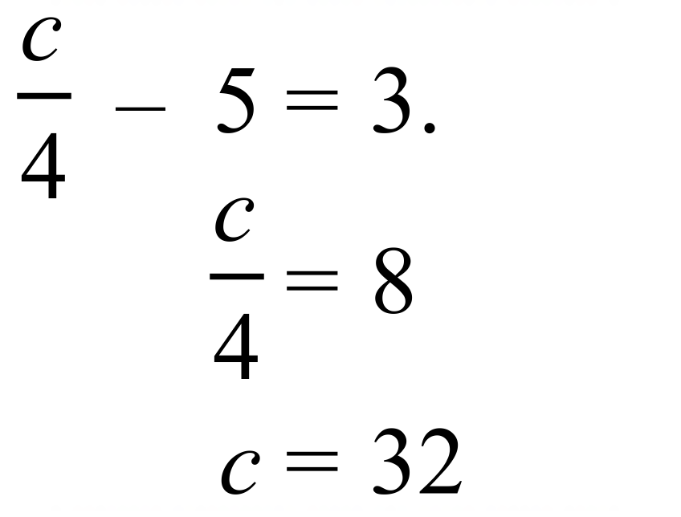 | D
 | 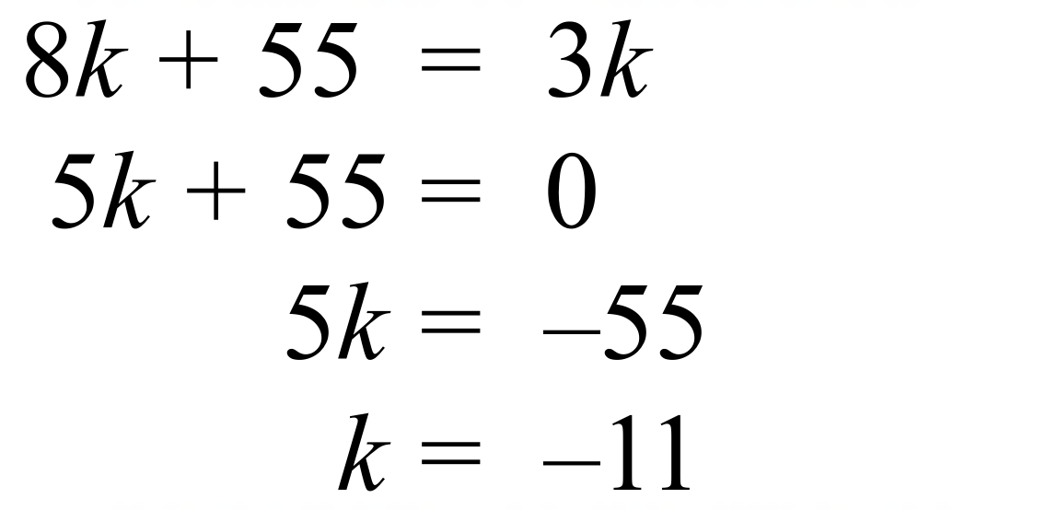. | A
 | Line 2 should read 7m = –35 + 14  Which leads to a correct answer of m = –-3 | B
 | 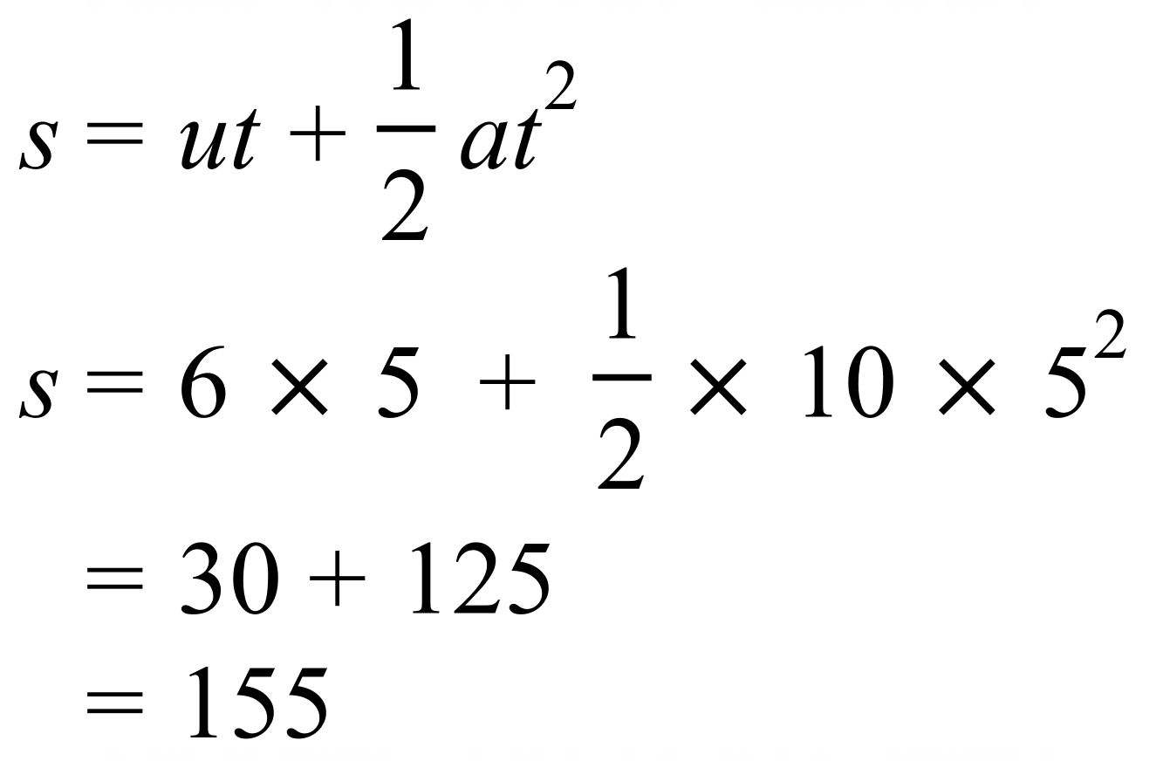 | B
 | Arrow to left indicates less than, and shaded circle indicates it can also be equal to, so . | C
 | 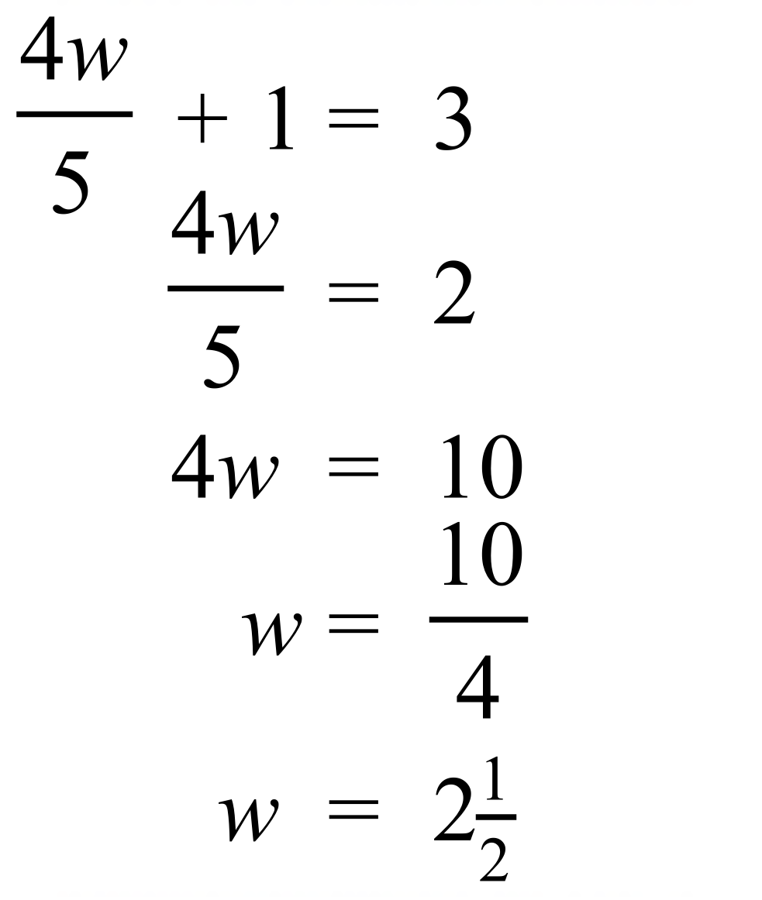 | A
 | 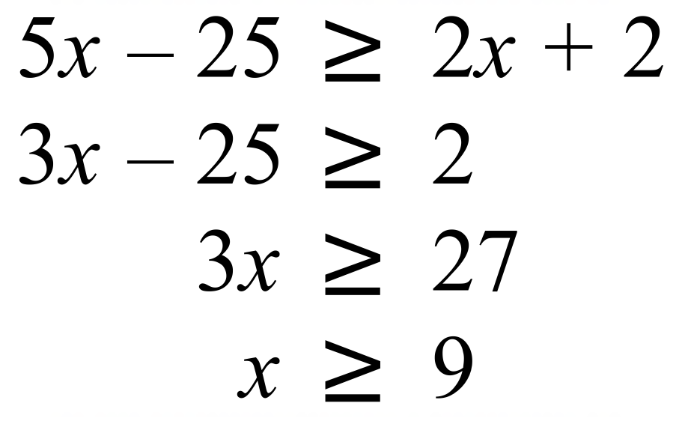 | D
 |  | C
 | 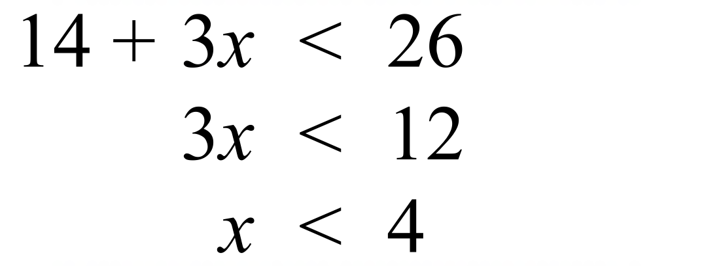 | B
 | 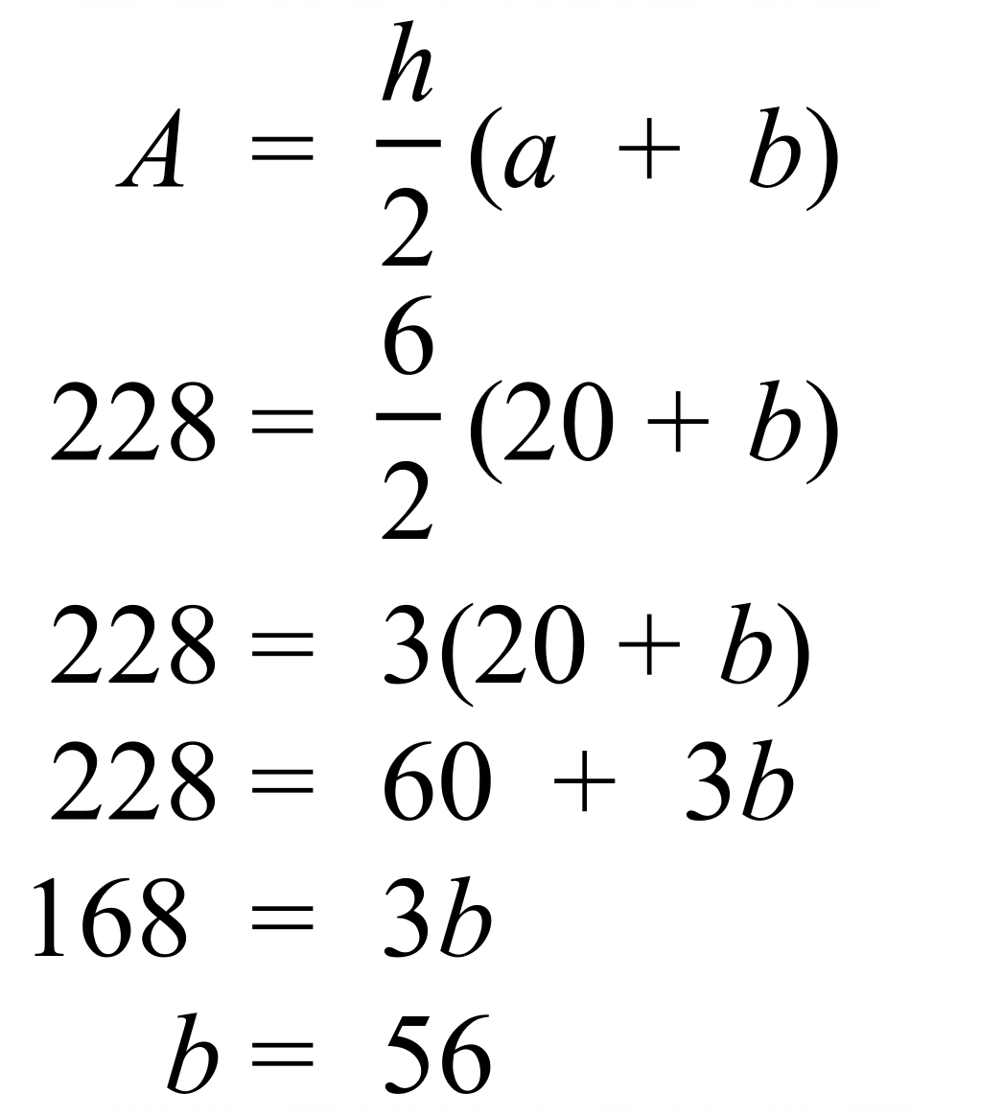 | C
 | 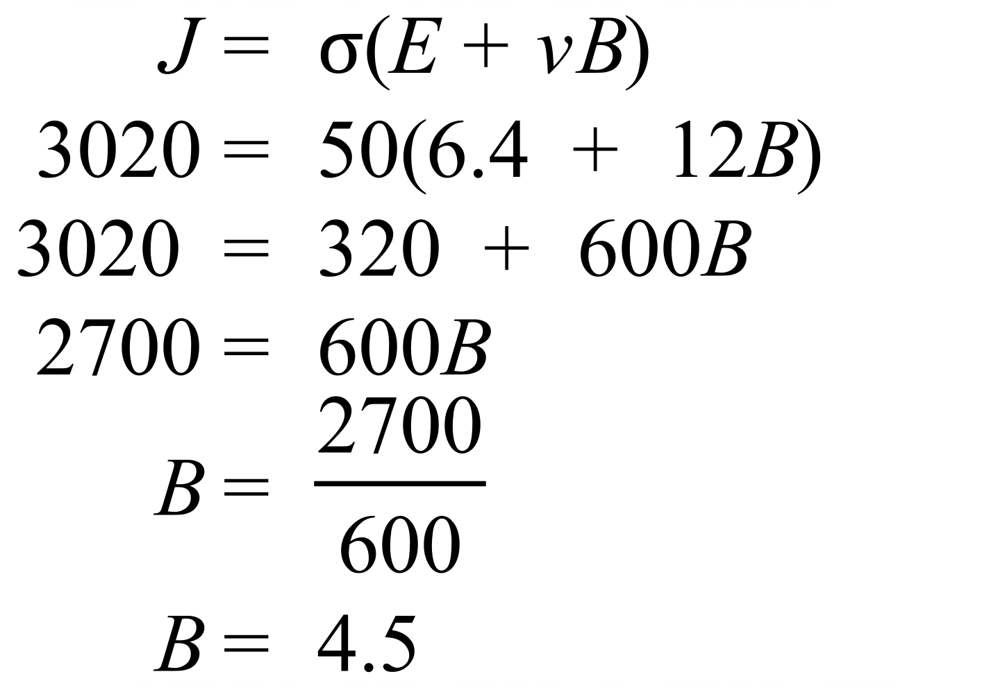 | A
 | 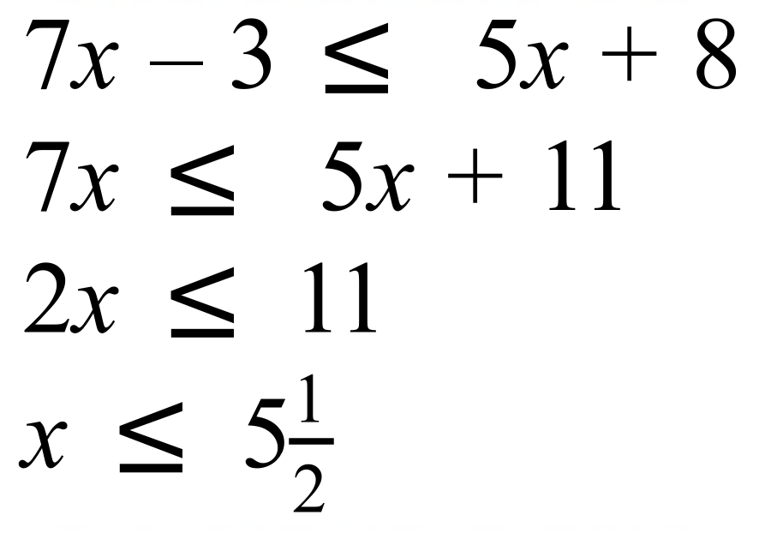 | C
 | 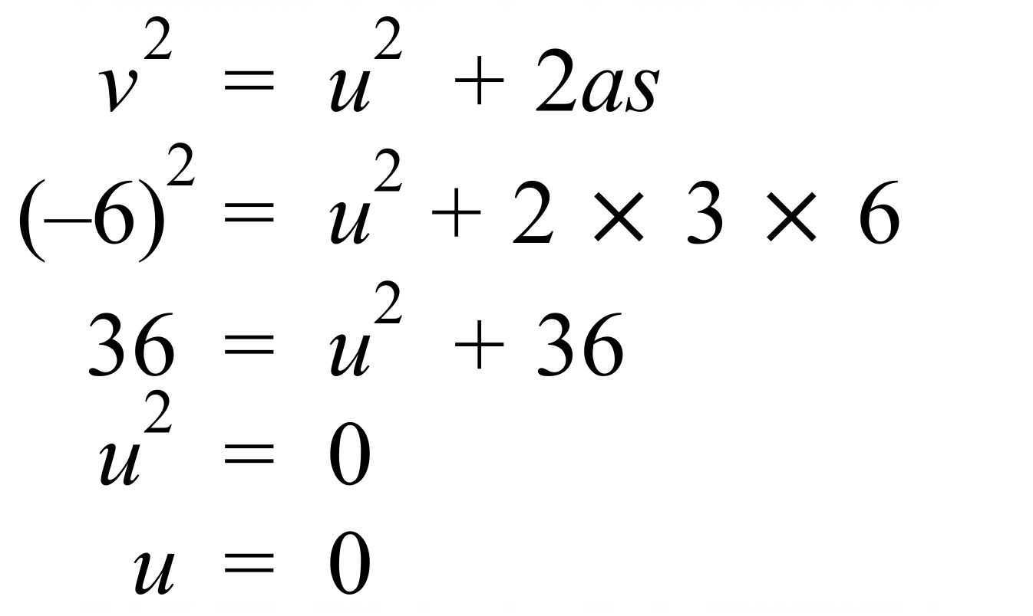 | B
 | 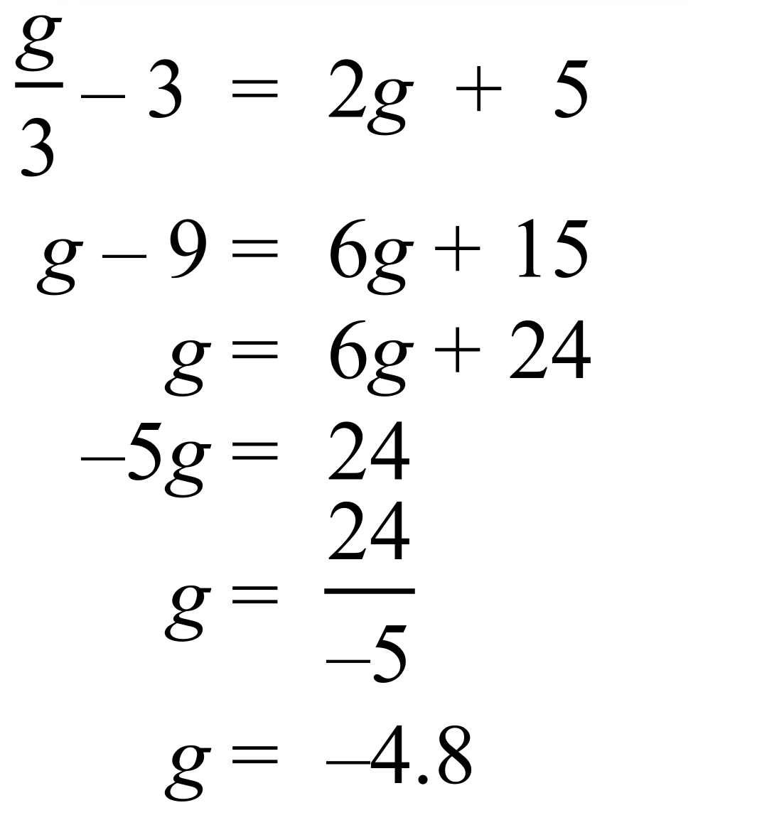 | A
 | 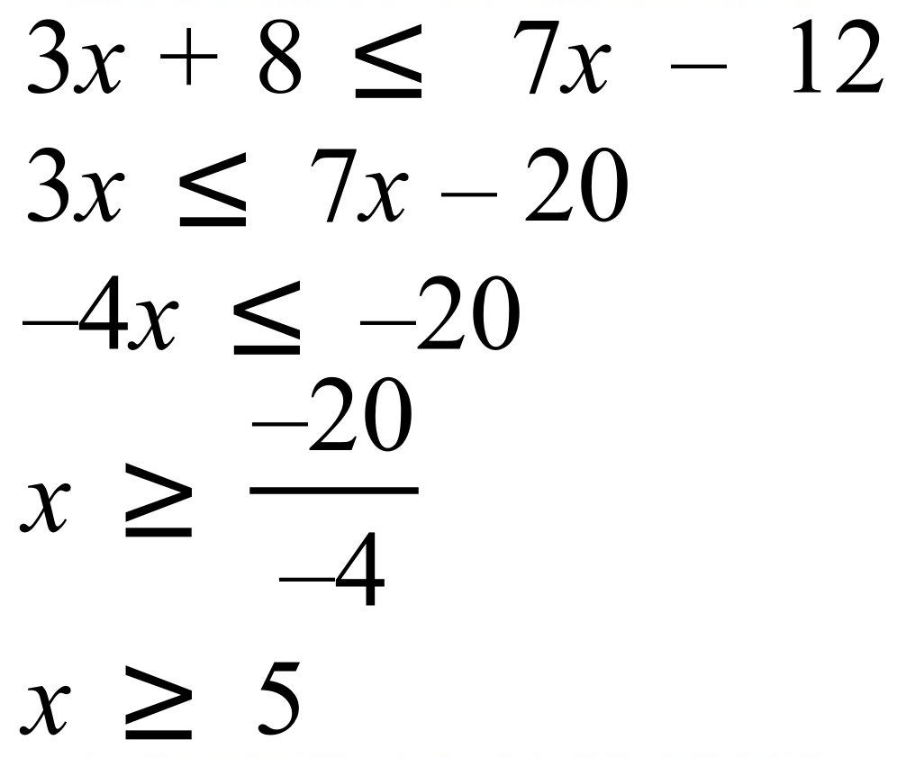 | D

School Name
Mathematics 2017
Multiple Choice Answer Sheet
Linear Equations
Name _____________________________________________
Completely fill the response oval representing the most correct answer.
1. A B C D
2. A B C D
3. A B C D
4. A B C D
5. A B C D
6. A B C D
7. A B C D
8. A B C D
9. A B C D
10. A B C D
11. A B C D
12. A B C D
13. A B C D
14. A B C D
15. A B C D

School Name
Mathematics Test 2017
Year 9 | Linear Equations | Calculator Allowed  Longer Answer  Section
ANSWERS
Question | Working and Answer | Marks
1. | (a)  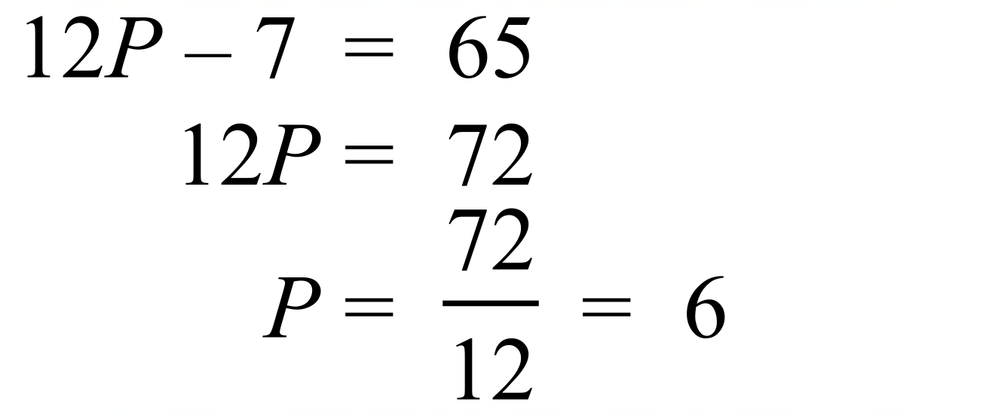 | 2 marks for correct answer with working.  1 mark for working with a single error.
 | (b)  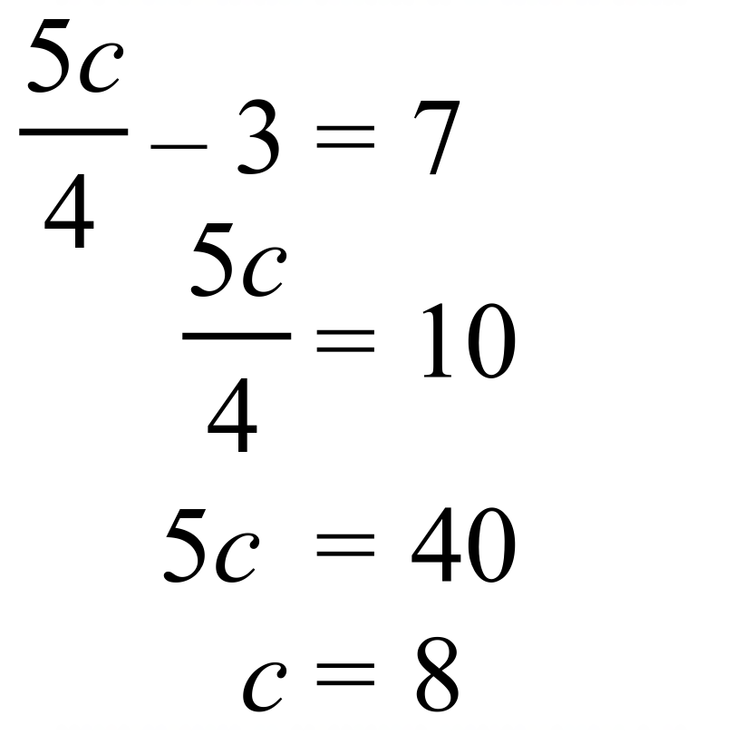. | 2 marks for correct answer with working.  1 mark for working with a single error.
 | (c)  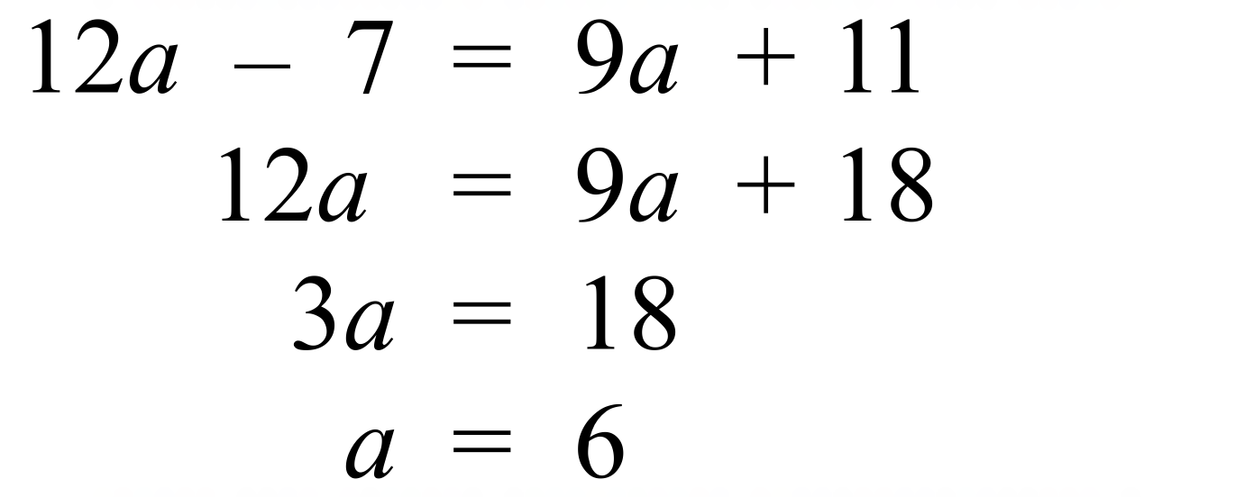 | 2 marks for correct answer with working.  1 mark for working with a single error.
 | (d)  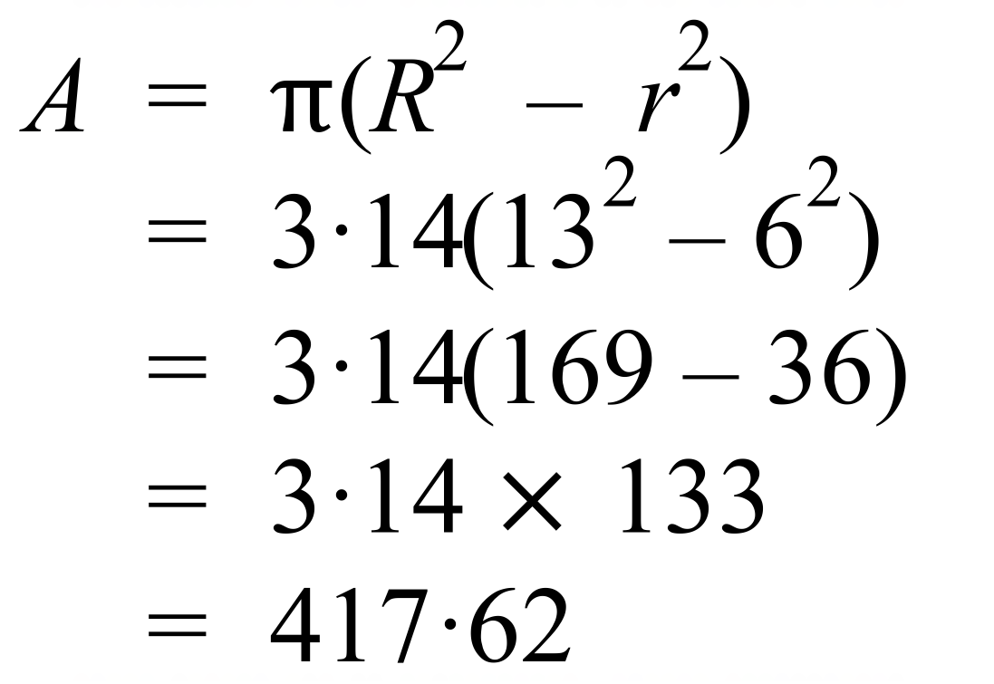 | 2 marks for correct answer with working.  1 mark for working with a single error.
2. | (a)  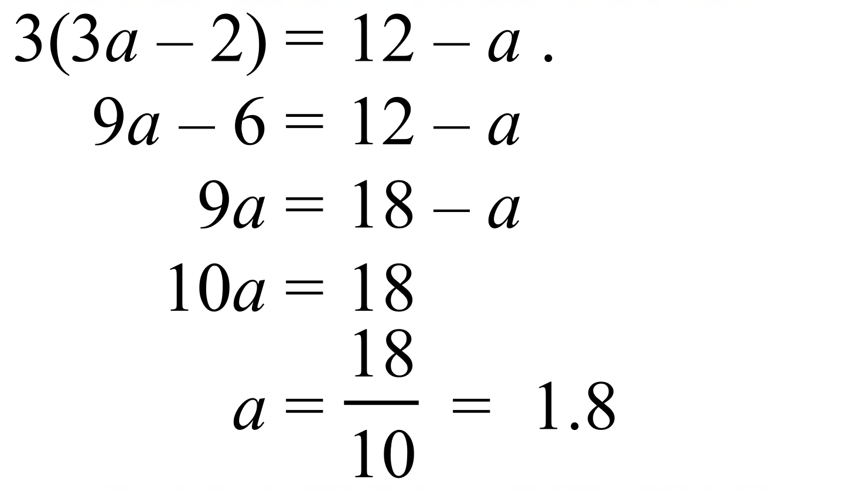 | 3 marks for correct answer with working.  2 marks for working with a single error in logic or calculation  1 mark for working with some correct logic.
 | (b)  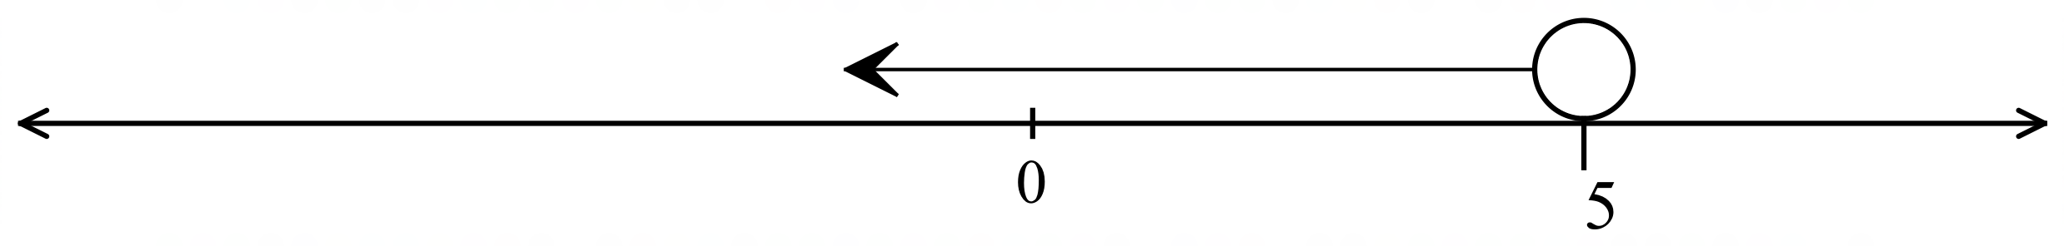 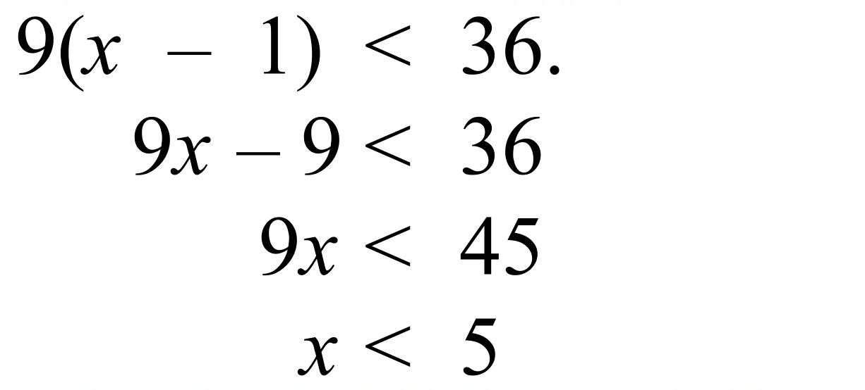 . | 3 marks for correct answer with working and correct graph.  2 marks for working with a single error in logic or calculation or for correct answer with error in graph  1 mark for working with some correct logic.
 | (c)  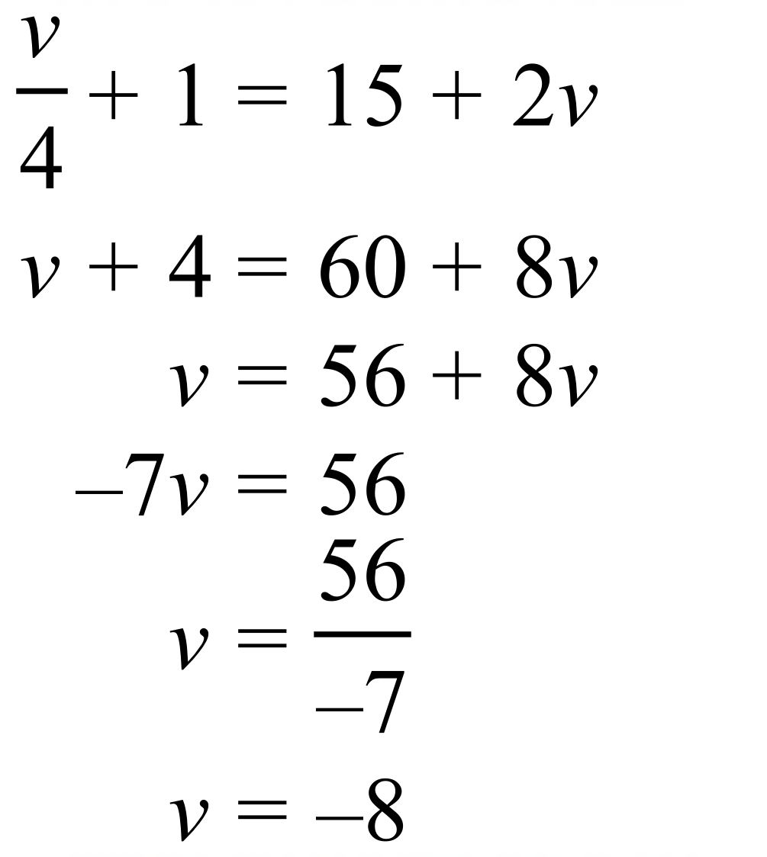 | 3 marks for correct answer with working.  2 marks for working with a single error in logic or calculation  1 mark for working with some correct logic.
 | (d)  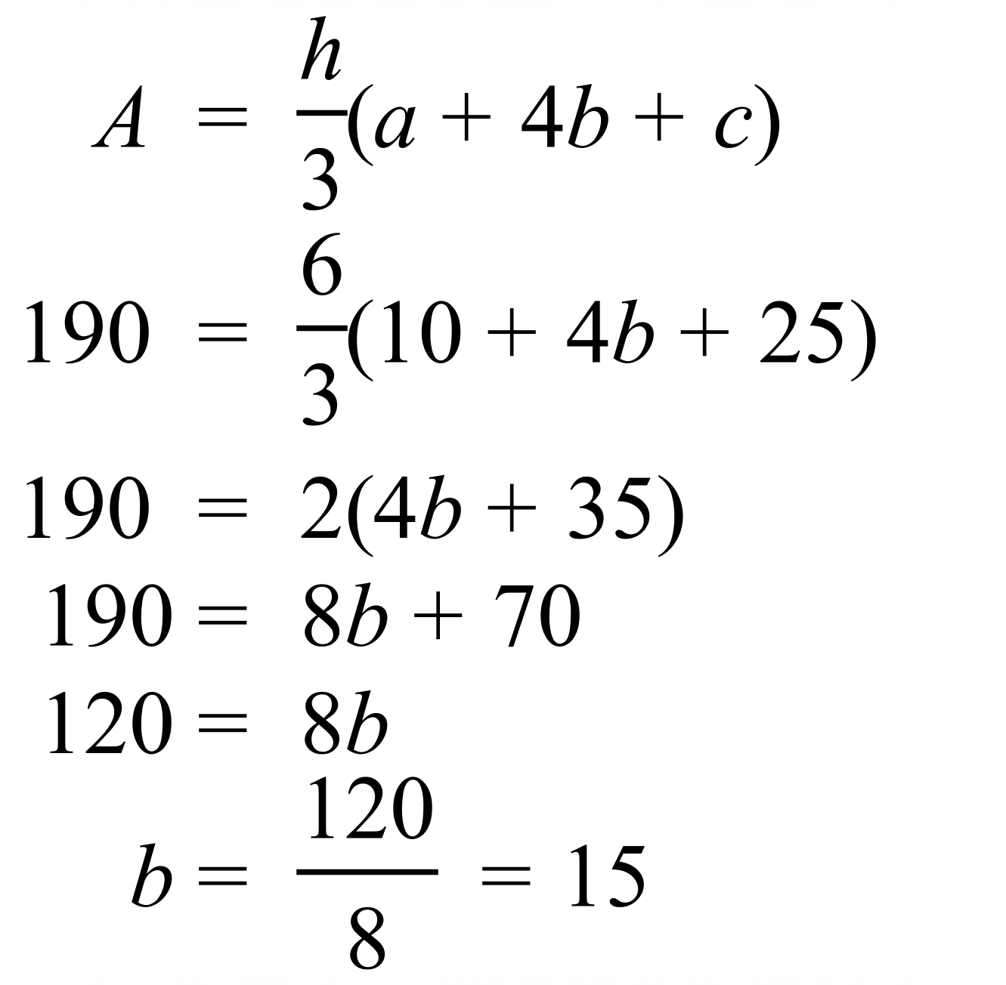 | 3 marks for correct answer with working.  2 marks for working with a single error in logic or calculation  1 mark for working with some correct logic.
3. | (a)  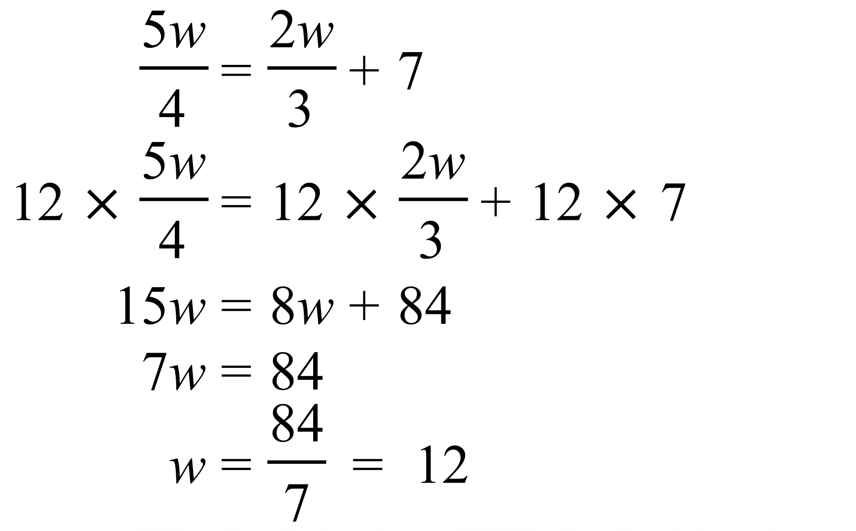. | 3 marks for correct answer with working.  2 marks for working with a single error in logic or calculation  1 mark for working with some correct logic.
 | (b) (i) 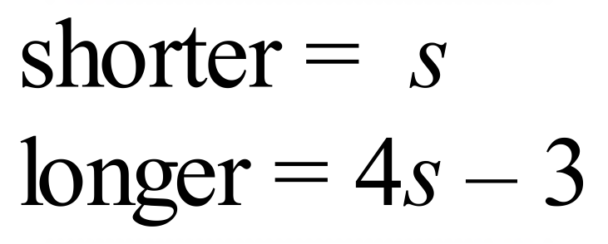  (ii) 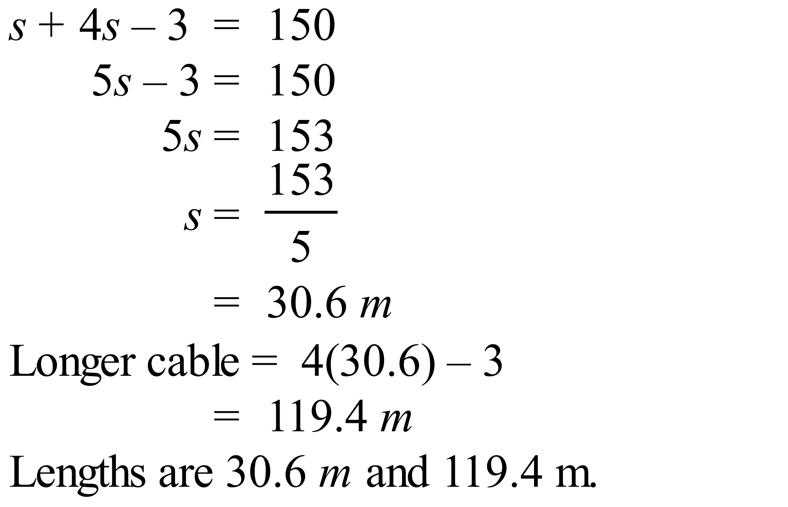 | (i) 1 mark for correct answer  (ii) 3 marks for correct answer with working.  2 marks for working with a single error in logic or calculation  1 mark for working with some correct logic.
 | (c)  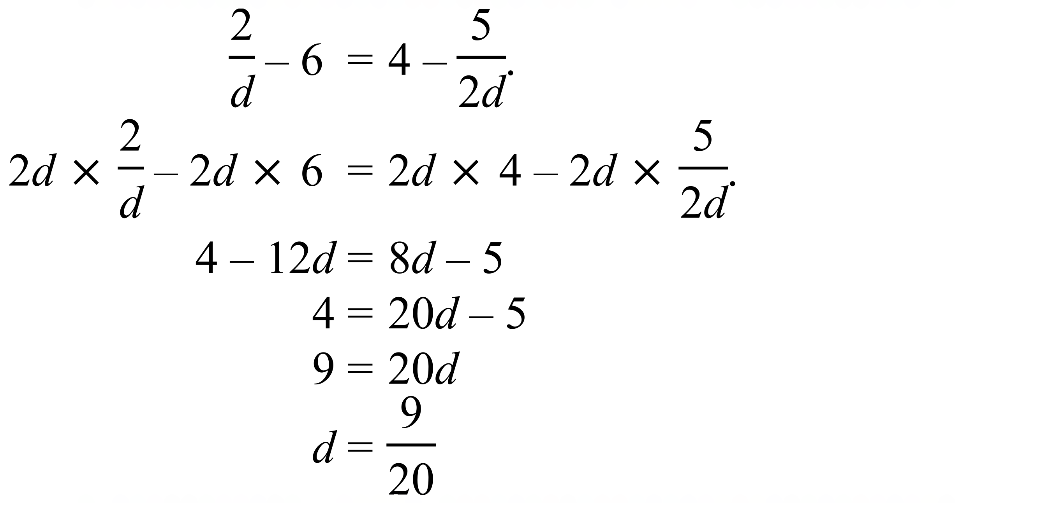 . | 3 marks for correct answer with working.  2 marks for working with a single error in logic or calculation  1 mark for working with some correct logic.
 | (d)  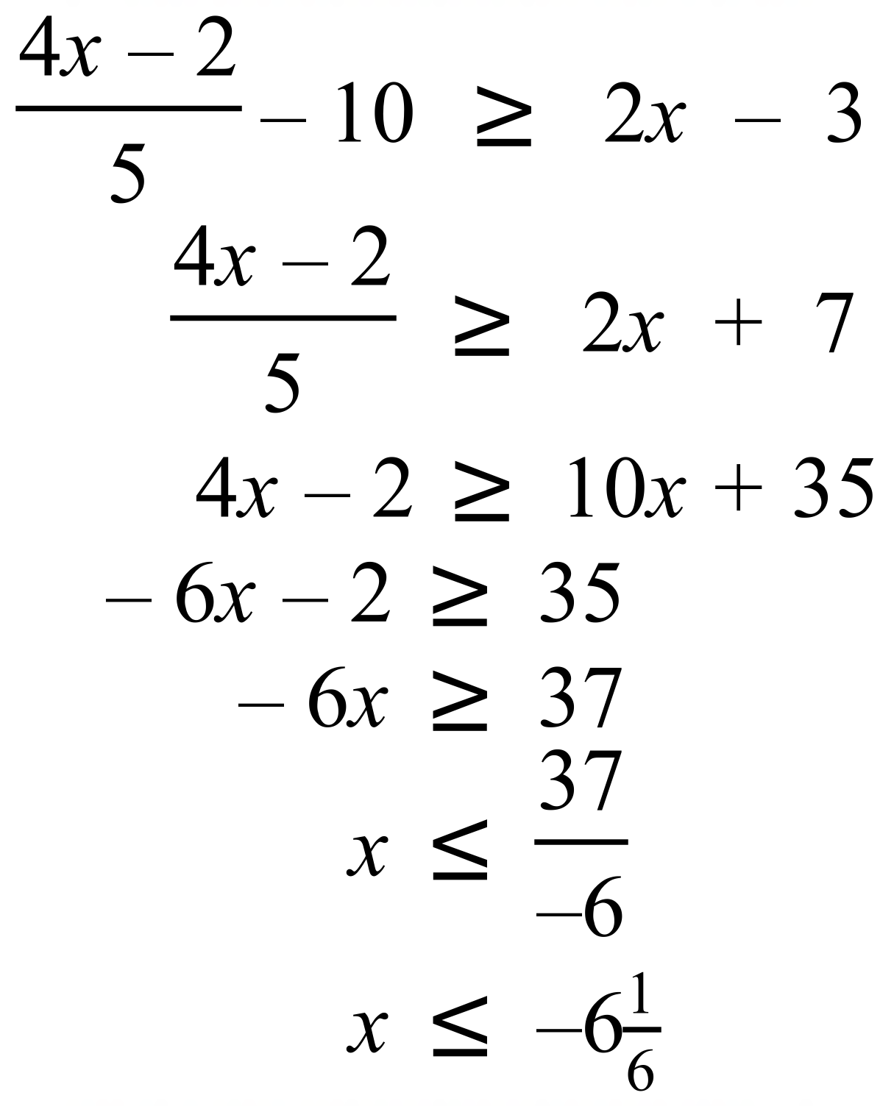 | 3 marks for correct answer with working.  2 marks for working with a single error in logic or calculation  1 mark for working with some correct logic.

